Rule Classes
Departmental rule classes identify the type of transaction and are generally classified as journal entry types, cash receipt types or budget entry types.

Budget Entry Rule Classes

All budget class types restrict budget transactions to transfers within the same fund and
between revenue or expense accounts. The Budget Office must process budget transactions that increase the overall revenue or expense budget of an organization.

▪ BPE-Permanent Budget Adjustment for Expenses: Transfer of permanent budget between
organizations within the same fund. The transaction is limited to expense accounts. Expense
accounts begin with 5, 6 or 7. Caution: As a permanent transaction, this budget transaction will change future fiscal year budgets.
▪ BPR-Permanent Budget Adjustment for Revenues: Transfer of permanent revenue budget
between organizations within the same fund. The transaction is limited to revenue accounts. Revenue accounts begin with 4. Caution: As a permanent transaction, this budget transaction will change future fiscal year budgets.
▪ BTE-Temporary Budget Transfer for Expenses: Transfer of temporary expenditure budget
between organizations within the same fund. The transaction is limited to expense accounts.
Expense accounts begin with 5, 6 or 7. This rule class only affects budget in the current fiscal
year.
▪ BTR-Temporary Budget Transfer for Revenues: Transfer of temporary revenue budget between
organizations within the same fund. The transaction is limited to revenue accounts. Revenue accounts begin with 4. This rule class only affects budget in the current fiscal year.

Guidelines for Budget Reallocation Entries in Banner
for Appropriated State Funds (E&G, FACR and Auxiliary)
▪ Non-labor budget transfers (accounts beginning with a 6 or greater) should generally
remain in the summary budgetary (budget pool) account codes. These are 5 digit
accounts, rather than the more specific 6 digit accounts. Example: the budget for general supplies is budgeted in account pool 62000.

▪ There is no automated feed of Banner Position Control changes to the Banner Finance
system. Labor related budget entries must be keyed directly into the Banner Finance
system.

▪ Depending on how your org is budgeted, labor related budget entries can be made to
summary budgetary (budget pool) account codes or to detailed expenditure account
codes, i.e. 510110 Administrative Faculty; 511110 Teaching and Research Faculty; 520110
Classified Salaries, etc.

▪ When making labor related budget entries, generally the position number of the salary
being transferred is entered as the first 6 characters of the Description field.

▪ For labor related budget entries, corresponding fringe benefits calculations must be
budgeted as well. This is not an automatic calculation. Fringe benefit rates are the same
for faculty and classified staff. Current rates can be found on the Controller’s website.

Guidelines for Budget Reallocation Entries in Banner
for Appropriated State Funds (E&G, FACR and Auxiliary)
▪ Labor related budget entries on a permanent basis (BPE) should correspond with any PAF
adjustments, to keep Banner Finance original adjusted budget (i.e. permanent adjusted) in line with Banner Position control by organization. Banner Position control, NBAPBUD is updated by the Budget Office based on departmental and HR adjustments made to
NBAJOBS labor distribution (or PAF adjustments).

▪ Labor related budget entries on a current basis (BTE) should be done to keep Banner
Finance temporary budget (i.e. Banner INB Adjusted Budget column) in sync with current position budgetary needs by organization. These entries are reconciled to internal
departmental records.

▪ Banner Position Control has one amount for budget. The Banner Position control budget
should be kept equal to the permanent salary requirement. The current salary requirement is calculated only in internal departmental records.

▪ Department initiated budget entries are entered on Banner form FGAJVCM
form . The bank used for these transactions is DB. The Budget Period field should always be 01. An increase to budget is a plus (+) in the Debit/Credit field. A decrease to budget is a minus (-) in the Debit/Credit field.

Budget Reallocation Policy

Dollar Threshold | Type of Transaction | Approval
Up to $500,000 | Transactions within a single org unit | Dean or Director
$500,000 to $1,000,000 | Transactions within a single org unit | Vice President
$1,000,000 & Up | Transactions within a single org unit | President with  recommendation of  Vice President
Up to $1,000,000 | Transactions that cross org units or exec levels | Respective Vice  President
$1,000,001 & Up | Transactions that cross org units or exec levels | President with  recommendation of  Vice President &  review by Sr. VP  Finance
Up to $1,000,000 | Fixed costs reallocations (rent, insurance, etc.) | Sr. VP Finance with  Budget Office analysis
$1,000,001 & Up | Fixed costs reallocations (rent, insurance, etc.) | President with  recommendation of Sr.  VP Finance

Budget Reallocation Policy

▪

At the Dean or Director level, document approval in Banner may be delegated

to the appropriate fiscal administrator or fiscal staff.

▪ An org (organizational) unit refers to a school, such as Dentistry or Pharmacy, or
other senior management level administrative unit (Human Resources, Technology Services, etc.).

▪ An org unit may include separately budgeted activities. For example, the
departments of History and Mathematics are within the college of Humanities and Sciences.

▪ The term “executive level” refers to the key organizational levels, such as
President, Provost/Academic Affairs, Health Sciences, etc.

Entering Budget Entries
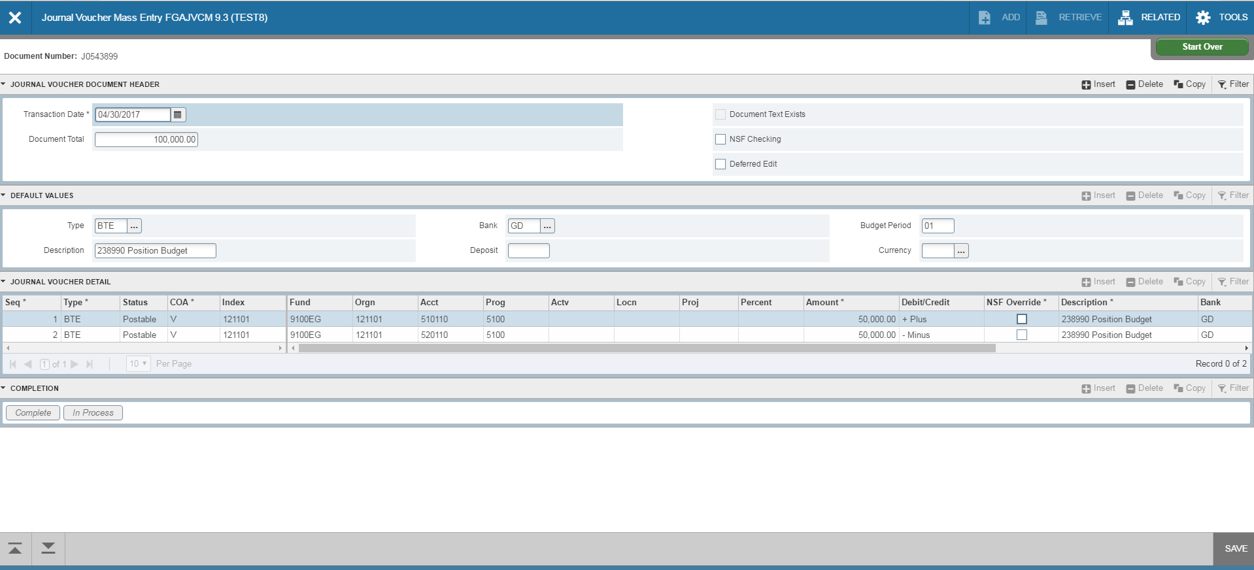
5
6
2
3
4
NEXT SECTION

2

3
4

5 6

NEXT SECTION

- Go to Banner form FGAJVCM. Click on Go.
- Transaction Date will auto-fill. Enter the Document Total. This is the total of all the transaction lines. For example, if you move 50,000 from one account to another, the total is 100,000.
- Type in the Rule Type: BPE, BPR, BTE or BTR. Type DB in the Bank field. Type in your Description.
- Type 01 in the Budget Period field. Click on Next Section down arrow.
- Tab to Index and enter the index. Tab to Acct and enter account.
- Tab to Amount and enter amount. For budget entries, a plus sign increases budget and a minus sign decreases budget. Tab through the rest of the fields on the line.
- To add the next line, click the down arrow on your keyboard or click insert. A new line will appear. Follow steps 4-6 to enter information for the new line.

Entering Budget Entries

- After entering all lines, click Save at the bottom right of the screen. Make sure the status on all lines updates to Postable. If any lines show the status as “Error”, you will need to resolve the error before moving forward.
- Select Related>Access Transaction Summary Info from the toolbar.

Entering Budget Entries
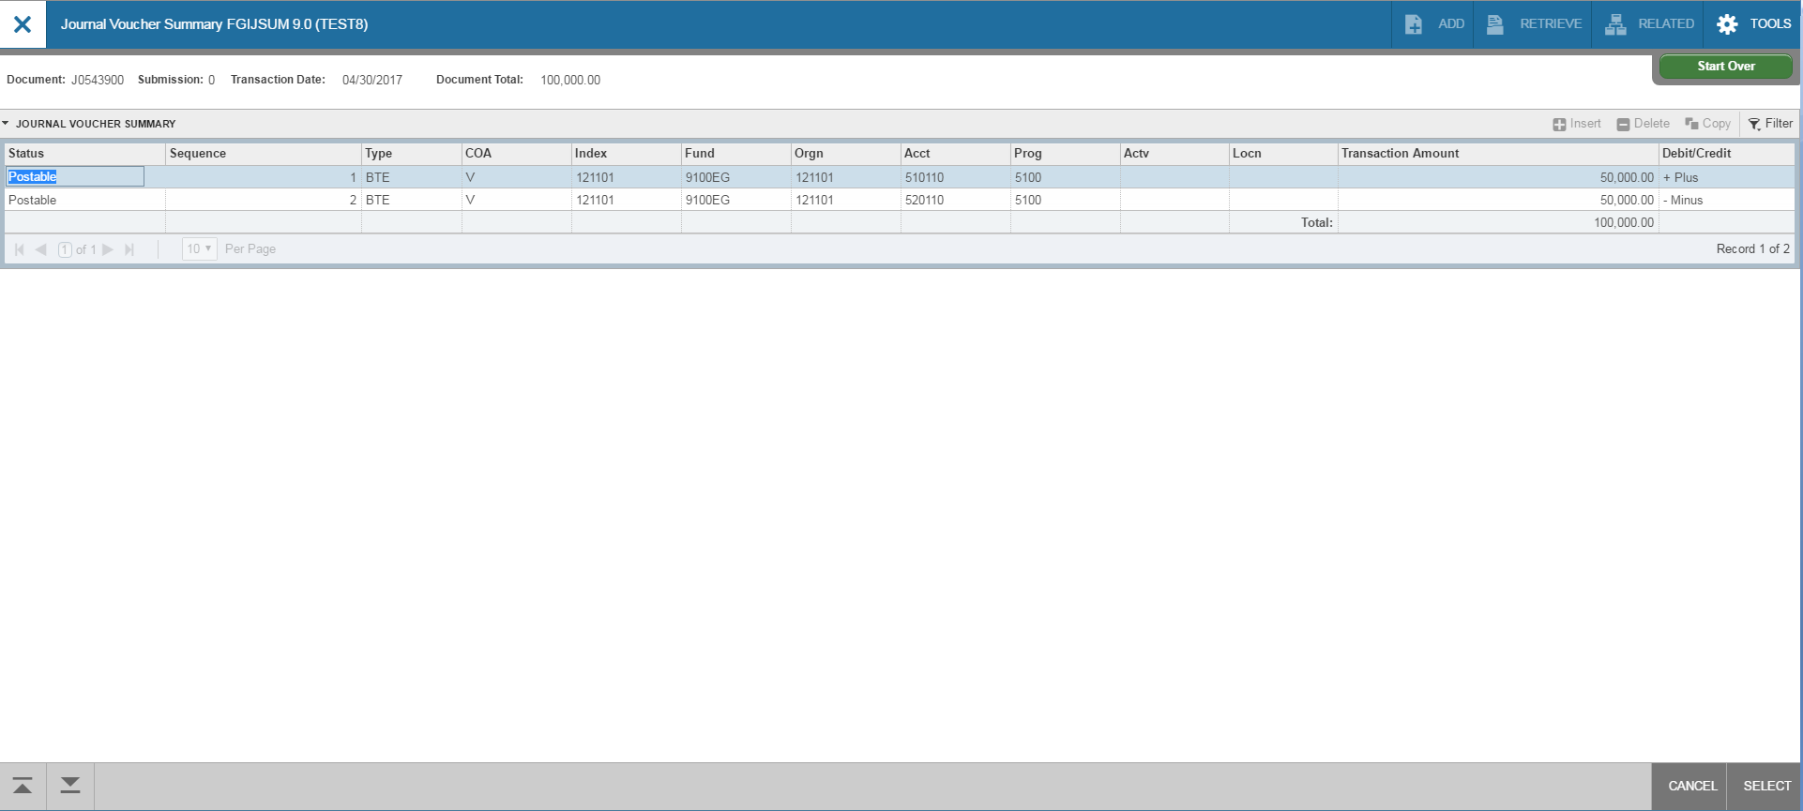
1
2
3
1

1

1

2

3

- Review your entry on this form. Make sure the Document Total equals the total of all lines you entered.
- Make sure that all lines of the transaction appear and that each has a status of Postable.
- Click on Cancel at the bottom of the page to exit this form and return to FGAVJCM.

Entering Budget Entries

2
1

- On FGAJVCM, click on the Save icon on the toolbar. If you are ready to submit the document for approval , click on Next Section down arrow.
- Click on Complete to submit the entry.

