Cash Receipt Rule Classes
▪ CCH-Departmental Cash Only Deposit: For cash deposits which are required to be segregated from
checks, MasterCard, Visa, American Express or Discover Credit Card deposits. The accounts used are
restricted to operating accounts that are not in the labor or internal transfer range. Unique deposit ticket numbers are required to be entered into the Deposit field. Use DP (BoA Deposit) in the Bank field. Budget Period field is blank. For a deposit to an org, use the plus (+) sign in the Debit/Credit field. To
reverse a deposit, use a minus (-) sign in the Debit/Credit field.
▪ CCK-Departmental Check Only Deposit: For check only deposits. The accounts used are restricted to
operating accounts that are not in the labor or internal transfer range. Unique deposit ticket numbers are required to be entered into the Deposit field. Use DP (BoA Deposit) in the Bank field. Budget Period field is blank. For a deposit to an org, use the plus (+) sign in the Debit/Credit field. To reverse a deposit, use a minus (-) sign in the Debit/Credit field.

Credit Card Rule Classes:
▪ CDS-Departmental Discover Card Deposit: For Discover Card Deposits.
▪ CMC-Departmental MasterCard/Visa Deposit: For MasterCard and Visa Deposits.
▪ CMX-Departmental American Express Credit Card Deposit: For American Express Credit Card Deposits.

The accounts used are restricted to operating accounts that are not in the labor or internal transfer range.
Use DP (BoA Deposit) in the Bank field. The Deposit field should indicate the cash collection point number (CCP) and the date of the deposit in the following format: “CCPMMDD.” Budget Period field is blank. For a deposit to an org, use the plus (+) sign in the Debit/Credit field. To reverse a deposit, use a minus (-) sign in the Debit/Credit field.

Entering Cash Receipts in Self Services
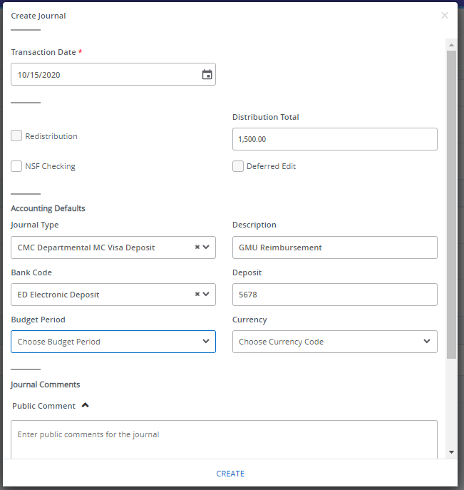

- Go to “My Journals” and click on “Create Journal.”
1

- Transaction Date will auto-fill. Enter the Distribution Total. This is the total of all the transaction lines. Departmental cash receipt entries are one line per deposit.
2

- Enter your Rule Class Type in “Journal Type”: CCH, CCK, CDS, CMC, CMX. Enter Bank Code DP. Type in your description. For the Deposit field, enter the deposit slip number for cash/checks, or the cash collection point number (CCP) and deposit date for credit cards, in the format “CCPMMDD.” Budget Period field is blank.
DP BoA Deposit
3

- Click on “Create” to move on to the transaction line details.
Entering Cash Receipts in Self Services
4

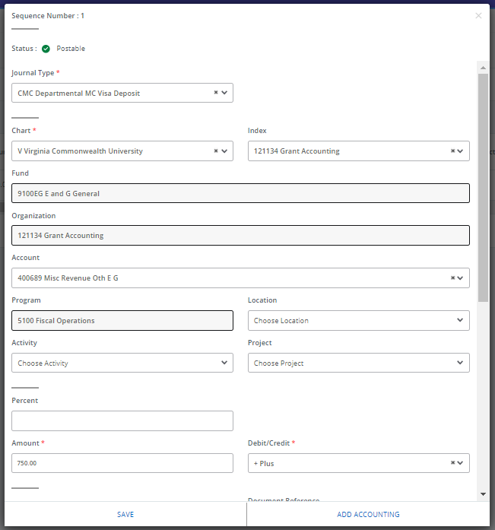

- Enter your index, account, amount, and description.
1

- For cash receipt entries, use the plus (+) and minus (-) indicators in the Debit/Credit field.

- Scroll down and enter a line description and the unique deposit number.

- Click “Add Accounting” to move on to a new transaction line
4
2
Entering Cash Receipts in Self Services
- After completing all lines, Click “Save.”
- The journal summary will display for your review. Ensure the “Total” in the header agrees to the “Accounting total” of the transactions you entered. Check that the status of each line is a green check mark (i.e., Postable). If necessary, you can edit lines by clicking on them.
- When ready to submit the journal for approval, click “Submit Journal.”
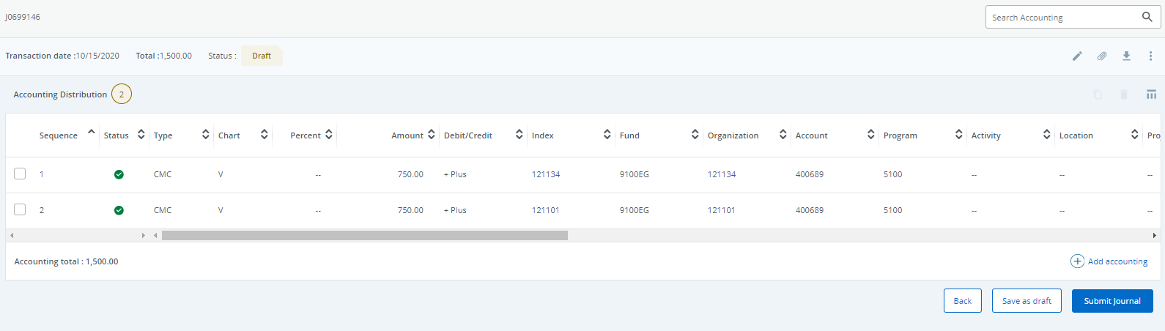
3

