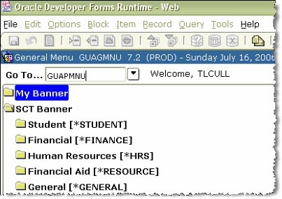
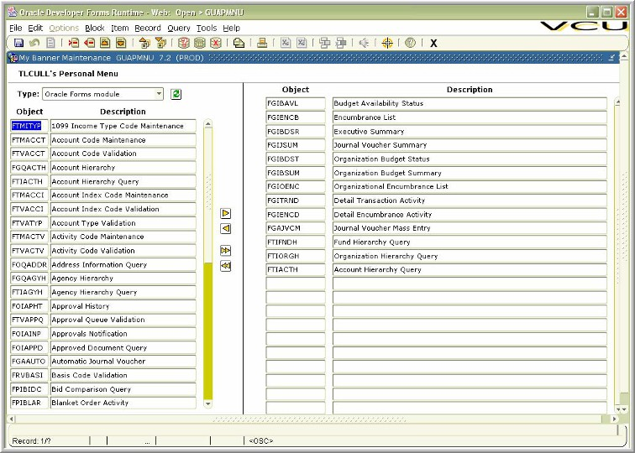
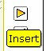
Customizing My Banner

Users can set up the forms, tables or processes used
most often, then return to them using My Banner.
The preferences are saved under the user’s login ID.

Type GUAPMNU in the
Go To box to set up
preferences
In My Banner

To move a form from the left to the
right, double-click on the Descrip-
tion of the item to move. When the
print turns blue, click the insert but-
ton to shift the item to the right, My
Banner.
To remove the item from the right,
reverse the process. On the right
side, double-click the description
field of the item to be removed.
When the print turns blue, click the Delete button.
All available forms, tables, processes in Banner appear on the left, grouped by Type. Personal preferences appear on the right. Users can Query the list on the left to isolate groups of forms. For example, Enter a Query (F7) to search for Finance Forms. Type F% in the Object column. Execute the Query (F8) to see a list of Finance Forms.

Rename forms by clicking on the description field in My Banner. When the field turns blue, type in a new form name.
Hint: Banner will show the INB Form name on the title bar and on the web tree at the top of the screen. Use the INB Form name when
contacting the HELP Desk.

INB Forms, Tables & Processes
HR Forms Description Finance Forms Description

NBAPOSN Position Definition
NBAJOBS Employee Job (HRS 101, 102, 981 Screens)
NBIJLHS Labor distribution change history
NBIPINC Position Incumbent Inquiry
PEAEMPL Employee Information (HRS 101 Screen)
PEALEAV Employee Leave Balances (HRS 965
Screen)
PEIJHIS Employee Job History
PEIEHIS Employee History
PHIETIM Web Dept Employee Time Inquiry Form
POIIDEN Employee Search
PHILIST Pay Event List
PEISALH Employee Salary History
FGAJVCM Journal Voucher Mass Entry used for budget
reallocations, journal vouchers, cash receipts
FGIJVCD List of suspended Journal Vouchers
FGIBAVL Budget Availability Status (requires Account)
FGIBDSR Executive Summary
FGIBSUM Organization Budget Summary
FGIBDST Organization Budget Status
FGITRND Detail Transaction Activity
FTIIDEN Entity Name/ID Search
FGIOENC Organizational Encumbrance List
FGIENCD Detail Encumbrance Activity
FTIFNDH Fund Hierarchy Query
FTIORGH Organization Hierarchy Query

Research Forms Description FTIACTH Account Hierarchy Query
FRIGITD Grant Inception To Date
FRIGTRD Grant Transaction Detail
FGIDOCR Document Retrieval Inquiry
FRAGRNT Grant Maintenance

