Entering a Budget Entry in Self-Service 9
C Controller’s Office

Rule Classes
Departmental rule classes identify the type of transaction and are generally classified as journal entry types, cash receipt types or budget entry types.

Budget Entry Rule Classes

▪ All budget class types restrict budget transactions to transfers within the same fund and
between revenue or expense accounts. The Budget Office must process budget transactions that increase the overall revenue or expense budget of an organization.

▪ BPE-Permanent Budget Adjustment for Expenses: Transfer of permanent budget between
organizations within the same fund. The transaction is limited to expense accounts. Expense
accounts begin with 5, 6 or 7. Caution: As a permanent transaction, this budget transaction will change future fiscal year budgets.
▪ BPR-Permanent Budget Adjustment for Revenues: Transfer of permanent revenue budget
between organizations within the same fund. The transaction is limited to revenue accounts. Revenue accounts begin with 4. Caution: As a permanent transaction, this budget transaction will change future fiscal year budgets.
▪ BTE-Temporary Budget Transfer for Expenses: Transfer of temporary expenditure budget
between organizations within the same fund. The transaction is limited to expense accounts.
Expense accounts begin with 5, 6 or 7. This rule class only affects budget in the current fiscal
year.
▪ BTR-Temporary Budget Transfer for Revenues: Transfer of temporary revenue budget between
organizations within the same fund. The transaction is limited to revenue accounts. Revenue accounts begin with 4. This rule class only affects budget in the current fiscal year.

Guidelines for Budget Reallocation Entries in Banner
For Appropriated State Funds (E&G, FACR and Auxiliary)

▪ Non-labor budget transfers (accounts beginning with a 6 or greater) should generally
remain in the summary budgetary (budget pool) account codes. These are 5 digit
accounts, rather than the more specific 6 digit accounts. Example: the budget for general supplies is budgeted in account pool 62000.

▪ There is no automated feed of Banner Position Control changes to the Banner Finance
system. Labor related budget entries must be keyed directly into the Banner Finance
system.

▪ Depending on how your org is budgeted, labor related budget entries can be made to
summary budgetary (budget pool) account codes or to detailed expenditure account
codes, i.e. 510110 Administrative Faculty; 511110 Teaching and Research Faculty; 520110
Classified Salaries, etc.

▪ When making labor related budget entries, generally the position number of the salary
being transferred is entered as the first 6 characters of the Description field.

▪ For labor related budget entries, corresponding fringe benefits calculations must be
budgeted as well. This is not an automatic calculation. Fringe benefit rates are the same
for faculty and classified staff. Current rates can be found on the Controller’s website.

Guidelines for Budget Reallocation Entries in Banner
For Appropriated State Funds (E&G, FACR and Auxiliary)
▪ Labor related budget entries on a current basis (BTE) should be done to keep Banner
Finance temporary budget (i.e. Banner INB Adjusted Budget column) in sync with current position budgetary needs by organization. These entries are reconciled to internal
departmental records.
▪ Department initiated budget entries are enterer on Banner form FGAJVCM-Journal Mass
Entry form. The bank used for these transactions is DB. The Budget Period field should always be 01. An increase to budget is a plus (+) in the Debit/Credit field. A decrease to budget is a minus (-) in the Debit/Credit field.

Budget Reallocation Policy

Dollar Threshold | Type of Transaction | Approval
Up to $500,000 | Transactions within a single org unit | Dean or Director
$500,000 to $1,000,000 | Transactions within a single org unit | Vice President
$1,000,000 & Up | Transactions within a single org unit | President with  recommendation of  Vice President
Up to $1,000,000 | Transactions that cross org units or exec levels | Respective Vice  President
$1,000,001 & Up | Transactions that cross org units or exec levels | President with  recommendation of  Vice President &  review by Sr. VP  Finance
Up to $1,000,000 | Fixed costs reallocations (rent, insurance, etc.) | Sr. VP Finance with  Budget Office analysis
$1,000,001 & Up | Fixed costs reallocations (rent, insurance, etc.) | President with  recommendation of Sr.  VP Finance

Budget Reallocation Policy

▪ At the Dean or Director level, document approval in Banner may be delegate to the appropriate fiscal administrator or fiscal staff.
▪ An org (organizational) unit refers to a school, such as Dentistry or Pharmacy, or
other senior management level administrative unit (Human Resources, Technology Services, etc.).
▪ An org unit may include separately budgeted activities. For example, the
departments of History and Mathematics are within the college of Humanities and Sciences.
▪ The term “executive level” refers to the key organizational levels, such as
President, Provost/Academic Affairs, Health
- Log into Banner 9 Self-Service through “myVCU” found on the VCU homepage. https://www.vcu.edu/

- Click on “eServices/VCU Self Service”.
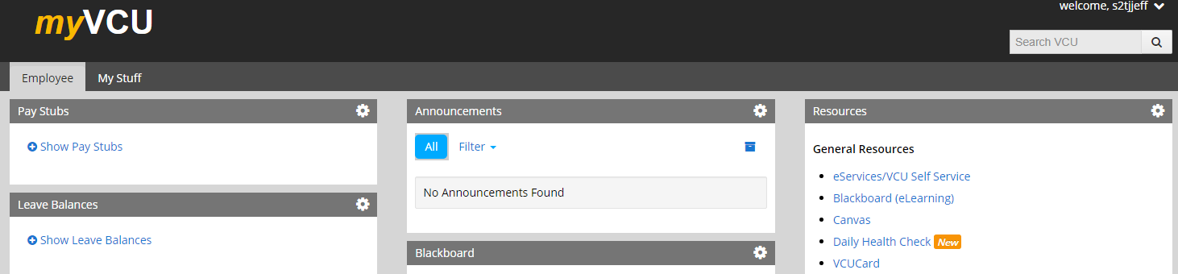

- Navigate to the Finance page using the menu at the top
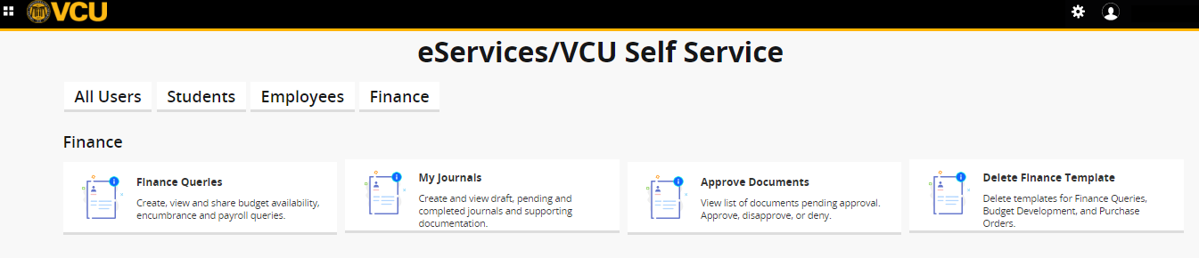
- Click on “My Journals” to create a budget entry

My Journal Page
- Use “My Journals” section to create journals and view existing journals.
- My journals has three sections:
  - Draft journals
  - Pending Journals
  - Completed Journals
- To view view more journals, click more View More.
- Click on Create Journal in the upper right corner.
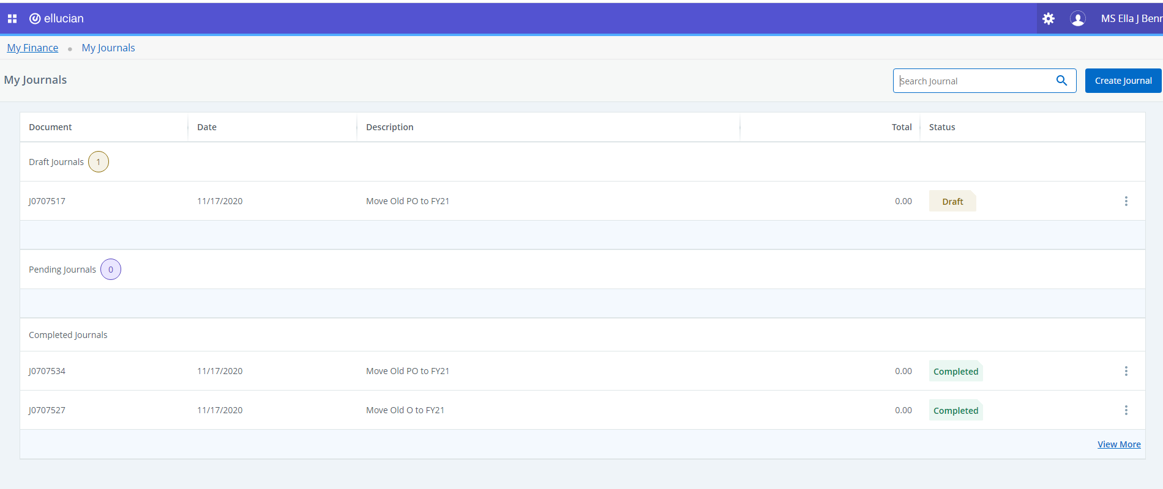
Header Information Page
- Use the Header information page to create a journal’s header information, and also edit and view the details.
- You can begin filling accounting defaults while creating sequences.
- Transaction Date will auto-fill.
- Type in the Distribution Total. This is the total of all transaction lines so if you move 50,000 from one account to another, the total is 100,000.
- Type in the Rule Type: BPE, BPR, BTE or BTR
- Type in Description
- Type in Bank Code DB
- Type 01 in the Budget Period field.
- Optional: Enter information in the Public or Private Comment fields
- Click CREATE.

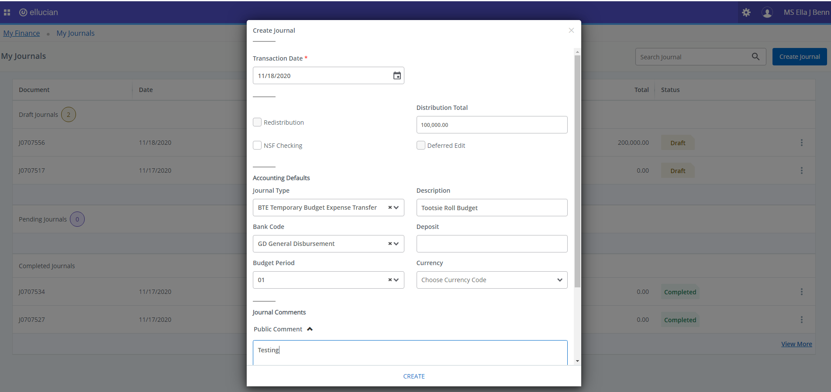
DB BoA Disbursement
Accounting Information Page
- Use the Accounting information page to create a journal’s accounting information, and also edit and view the details.
- The accounting defaults that you enter on the header page will default for each accounting sequence.
- Sequence number
- Status: Once completed it will show Postable or Error
- Type in Index. Fund, Org, and Program will auto-fill.
- Enter account code.
- Use scroll bar to the left to scroll down to the amount and debit/credit fields.
- Enter amount.
- For budget entries, a plus sign increases budget and a minus sign decreases budget.
- Click SAVE OR ADD ACCOUNTING (to create another sequence).

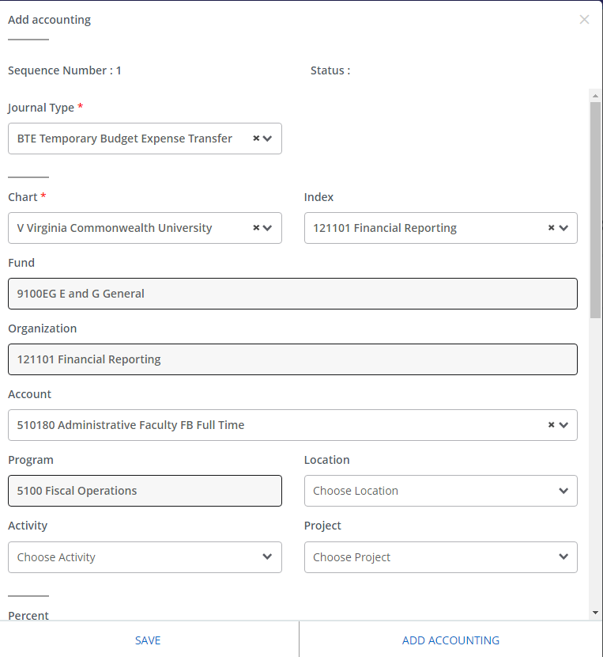

Accounting Information Page (con’t)
- After creating an accounting sequence, you can create another sequence by clicking Add Accounting without closing the overlay window.
- Click SAVE OR ADD ACCOUNTING (to create another sequence).
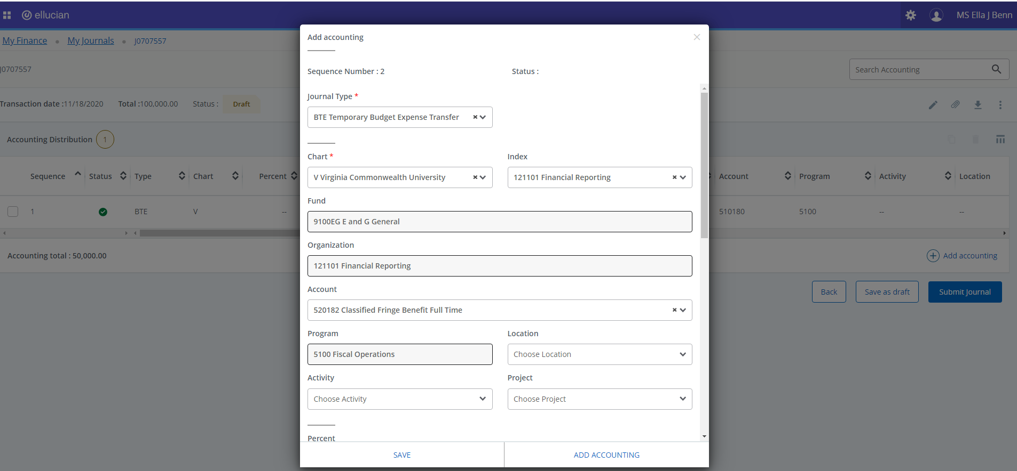
Summary Page
- The Summary Page contains detailed information of the selected journals document.
- You can view and edit header and accounting information, view the journal details as a PDF, and download the details into an Excel spreadsheet.
1. Click on More actions icon to copy, reverse, delete, and recall the document.
- Use the bottom scroll bar to see the entire journal.
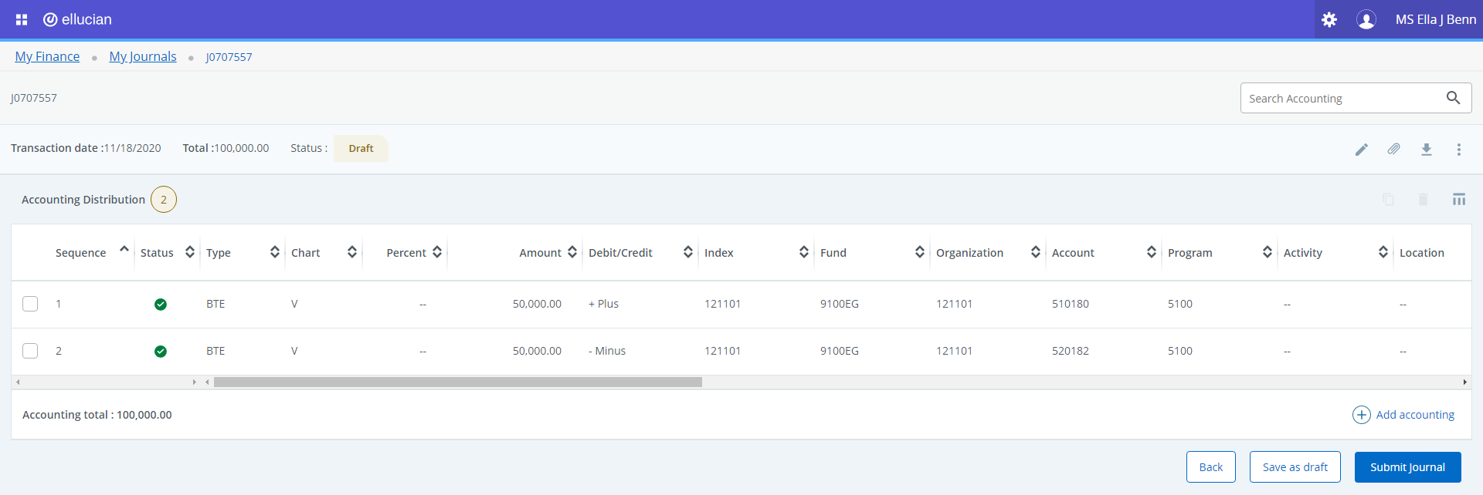
Summary Page (con’t)

- Click Save as draft to keep the document in the draft status. Click Submit to complete the document.
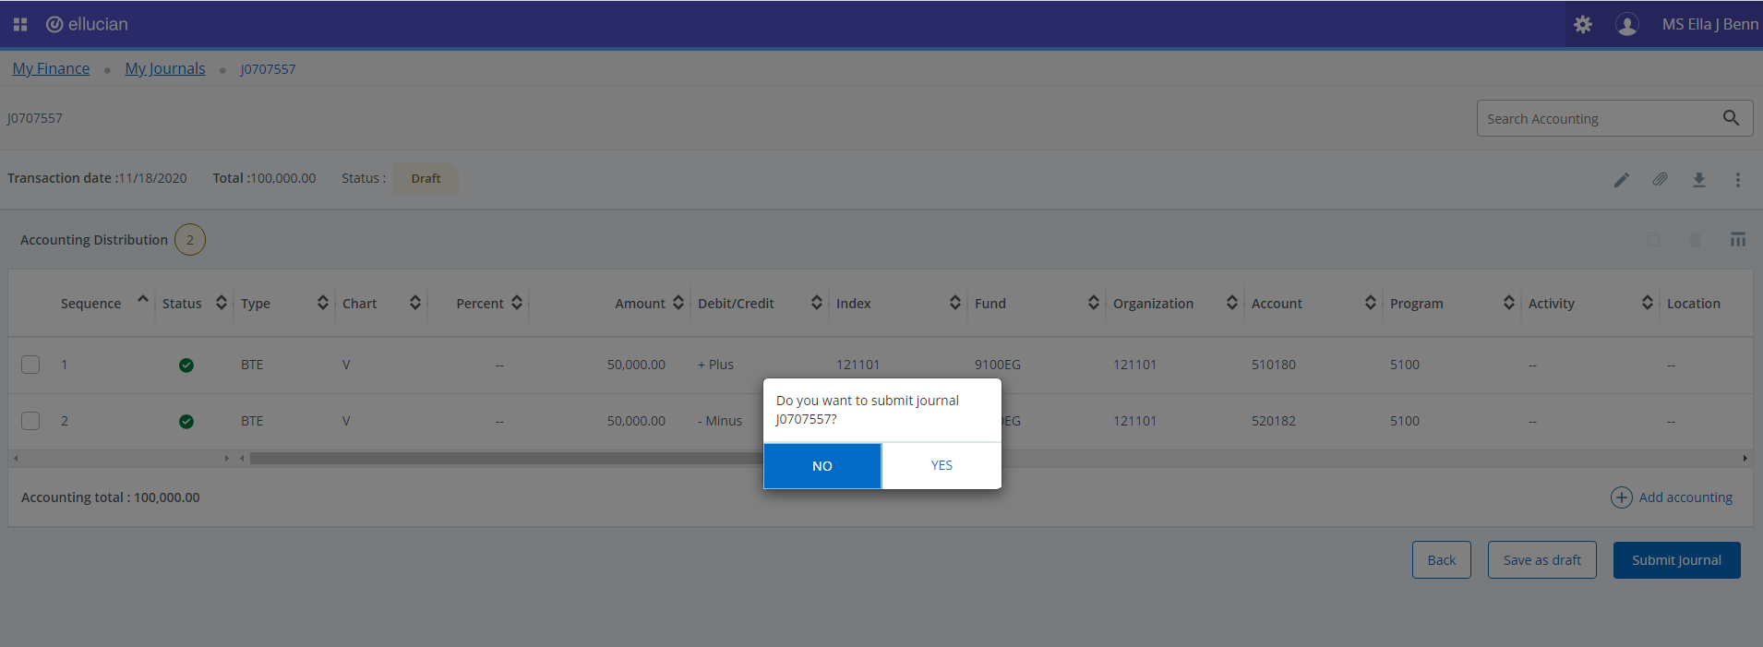
Summary page (con’t)

- Once you click Submit, you will receive a message in the upper right corner “Document J0xxxxxx completed and forwarded to the approval process.”
