Removing a Travel Encumbrance
There are instances where a travel encumbrance needs to be removed manually. For instance, if a travel pre-approval was not attached to the expense report, the
encumbrance will not liquidate automatically.
First, you will need to find out some specific information about the encumbrance you want to remove. Go to form FGIENCD and enter the document number (begins with Txxxxxxx). Click on Go.

Removing a Travel Encumbrance
From this form, note the Index, item number, sequence number, account, and balance. You’ll need this information to enter on Banner form FGAJVCD (Journal Voucher Entry).
- This must be done for each line of the encumbrance, if there are multiple items/sequence numbers. To get this information, check the bottom of the “Encumbrance Detail” section, and hit the right arrow button to view the next record(s).
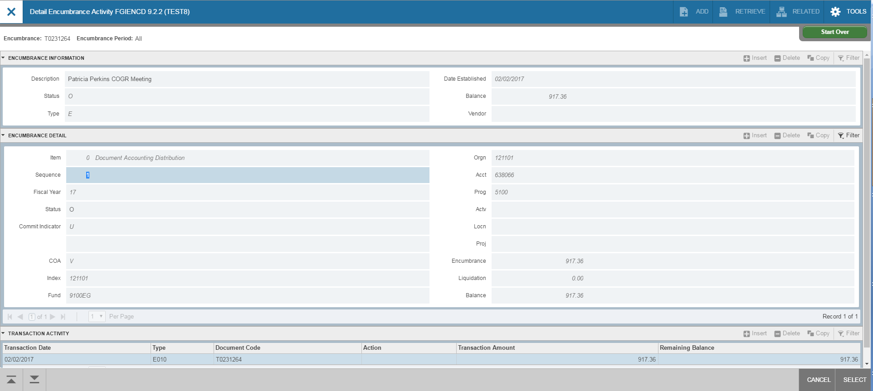

Removing a Travel Encumbrance

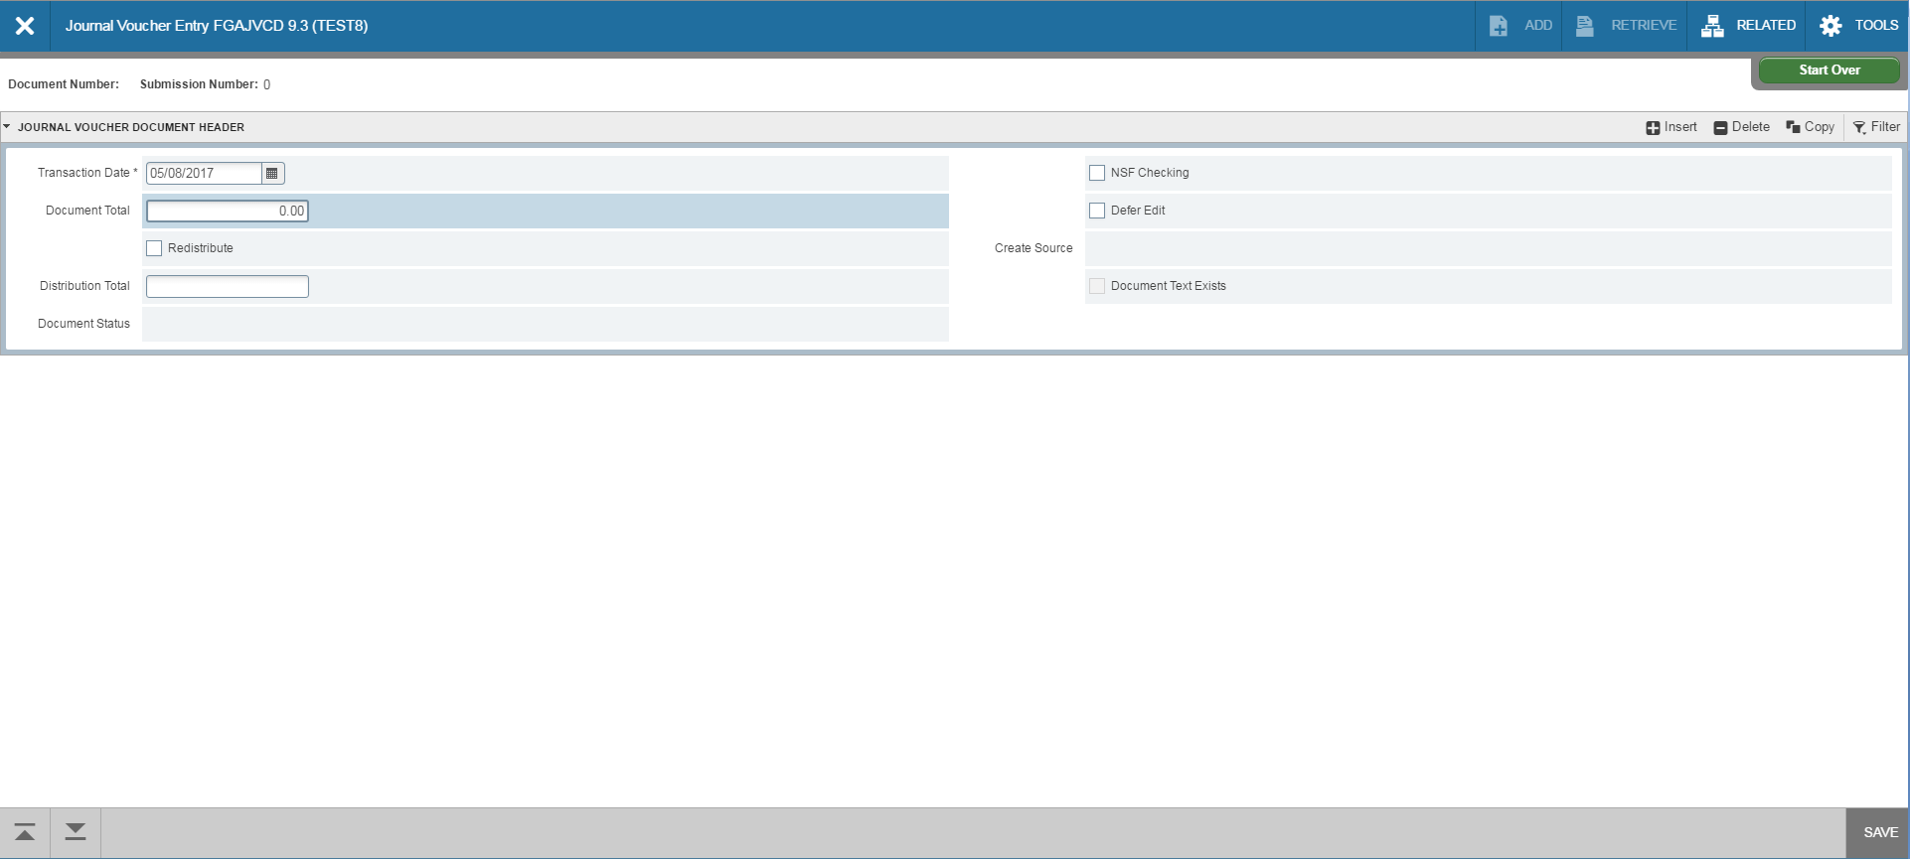
Go to form, FGAJVCD and click on Go. The Document Number will eventually self-
populate. The Transaction Date will auto-fill. Because this is an encumbrance
liquidation process, Total should equal zero. Click on Next Section down arrow.

Removing a Travel Encumbrance
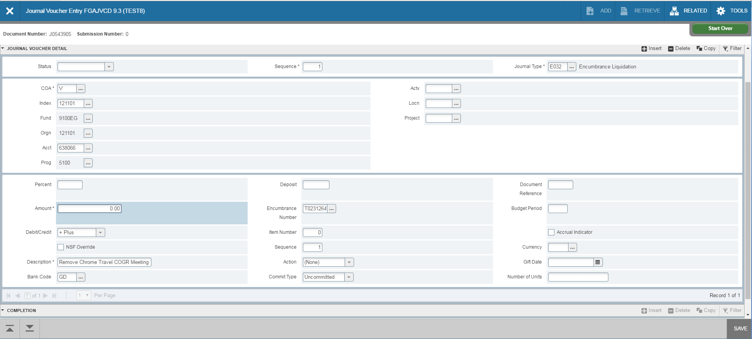
Leave Sequence blank (it will self populate) and tab to Journal Type. Enter E032. The COA (Chart of Accounts) will self populate with V. Type your index in the Index Field. Fund and Orgn will self-populate. Enter the account number in the Acct field. Tab to Amount and enter zero. For the Debit/Credit field, use the plus (+) sign to liquidate the encumbrance. Tab to Description and enter details.

Removing a Travel Encumbrance
The Bank Code is DB and will self-populate. Tab to Encumbrance Number and enter the Txxxxxxx number. Tab to Item Number (found on FGIENCD) and enter. Tab to Sequence (found on FGIENCD) and enter. Click Save at the bottom right of the screen. Make sure the status field updates to Postable.
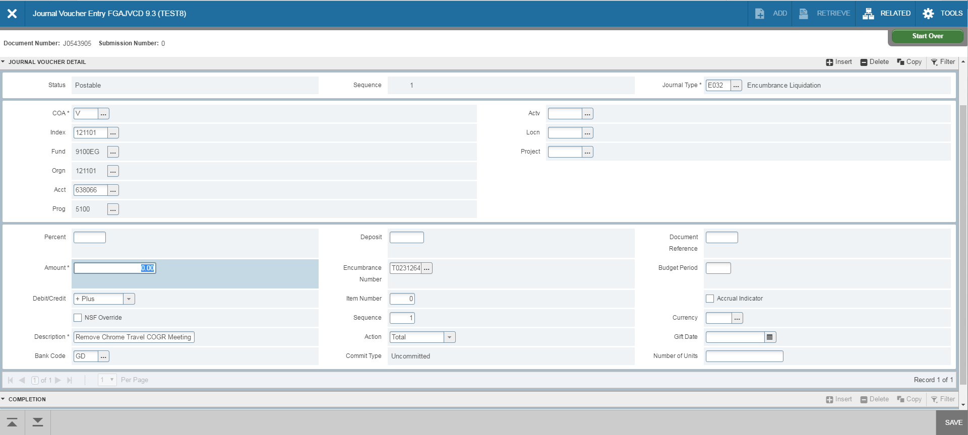
- If you need to remove multiple travel encumbrance lines, click on Insert to add a line. A blank form will appear to enter the new line. Follow the same steps to enter the new line.

Removing a Travel Encumbrance
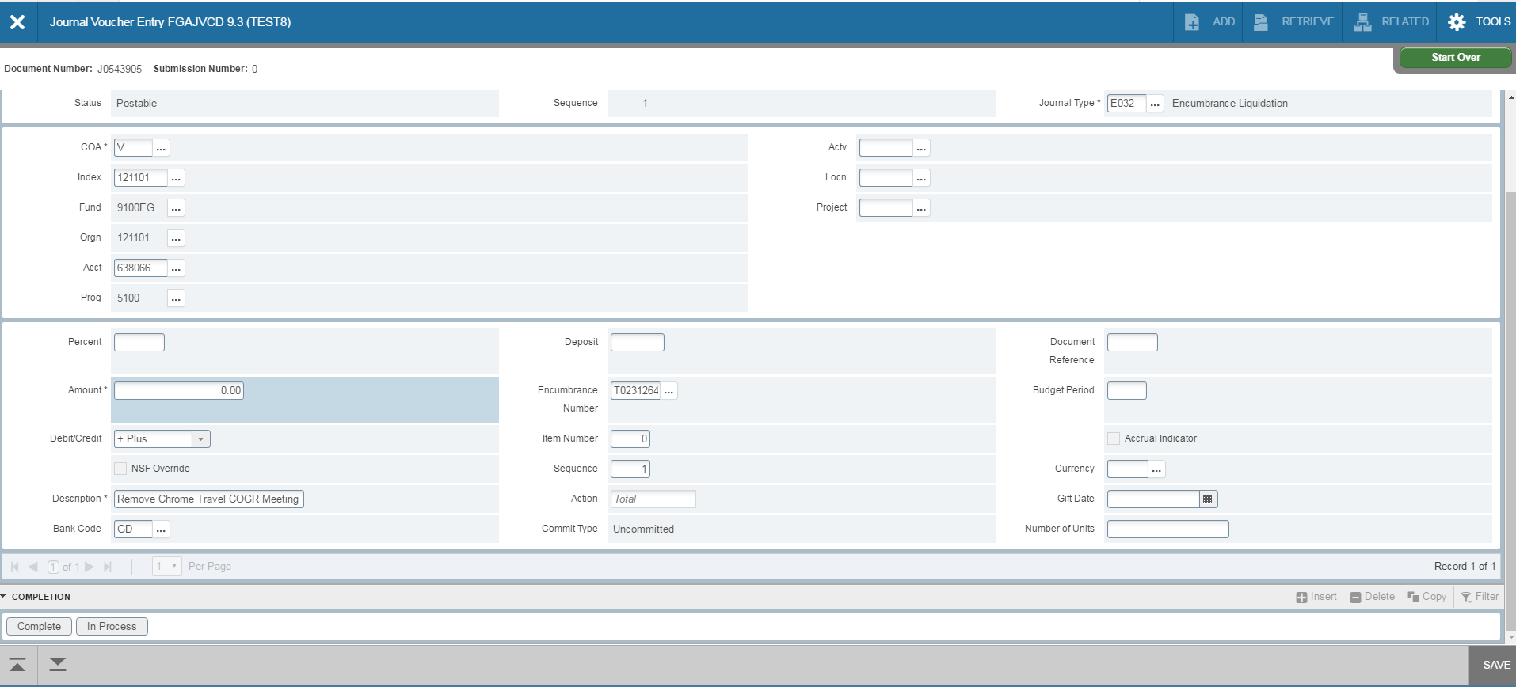
After all lines are entered, click on the Next Section down arrow. Note the Document Number for your records. Click on Complete to forward the entry to the approval queue. After document has been approved, check your Index to see if the encumbrance was removed properly.

Removing a Travel Encumbrance
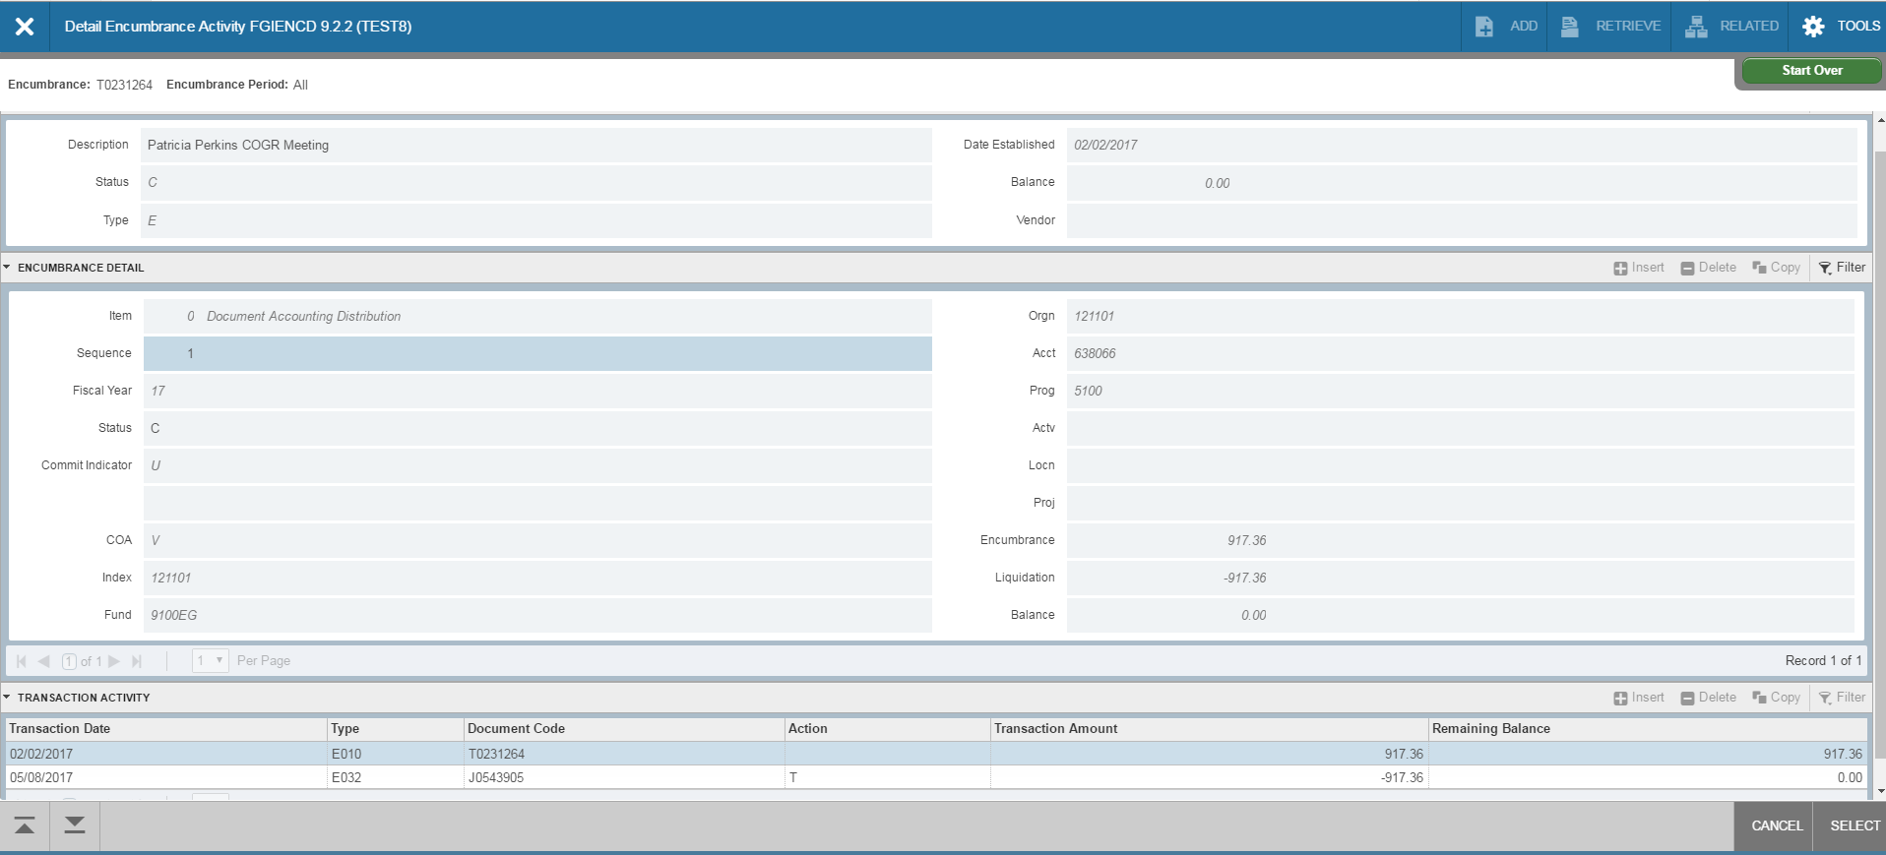
To ensure the encumbrance removed successfully after document has been approved, go to form FGIENCD and enter the document number (begins with Txxxxxxx). Click on Go. If travel encumbrance has fully liquidated, balance will equal zero.

