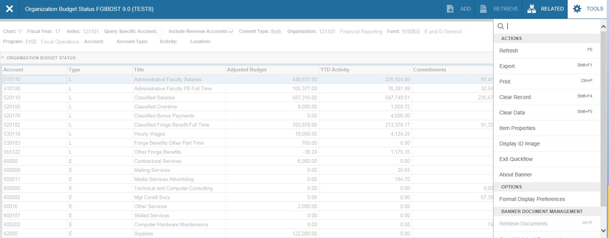Many Banner pages can be downloaded into an Excel spreadsheet. To do this, select “Tools” and Export
on the right side of screen. On other pages if this option is grayed out, you’ll know the page cannot be
downloaded.

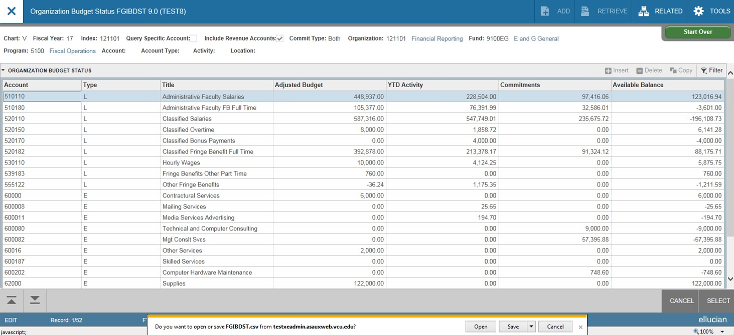The Budget Status page (FGIBDST), as well as many other pages, can be downloaded into an Excel
spreadsheet. To do this, select “Tools” and Export on the left side of screen. You will see a message appear on the bottom; select “open” or “save”. On other pages if this option is grayed out, you’ll know the page cannot be downloaded.

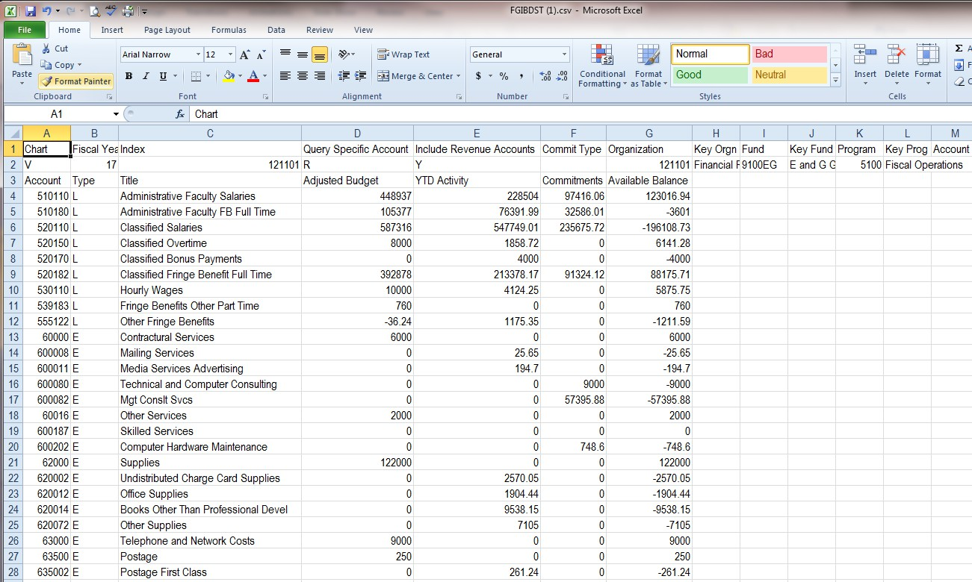The file will download with the column headings and you’ll need to adjust the column
widths as well as the number formatting.

