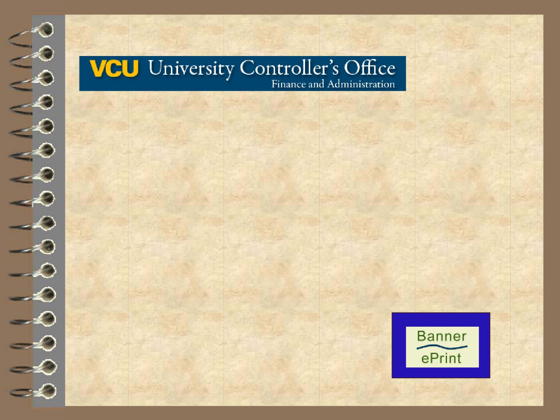

ePrint Guide

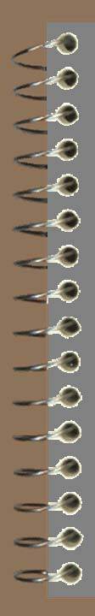
Overview

ePrint is a web based report distribution and archiving system. Using a web browser and the free Adobe Acrobat Reader®, ePrint users can
access, organize and view their monthly Banner organization reports in a format that is easy to read, search and print.
This guide includes information on basic ePrint navigation, search tools
and customization. Also included are sections on how to read and
interpret ePrint reports and how to download an ePrint text file to Excel.

1

Index

Logging into ePrint Selecting Reports Report Drill Down Saved Searches
Navigating ePrint
Viewing ePrint Reports How to Read ePrint Reports Configuring My ePrint
Saving an ePrint Report to Excel Troubleshooting

4
8
14
22
25
27
32
41
49
57

2

What You’ll Need to Get Started

Current Web Browsers:
Microsoft® Internet Explorer
Chrome®
Mozilla Firefox®

Acrobat Reader®

eID

eID password

3

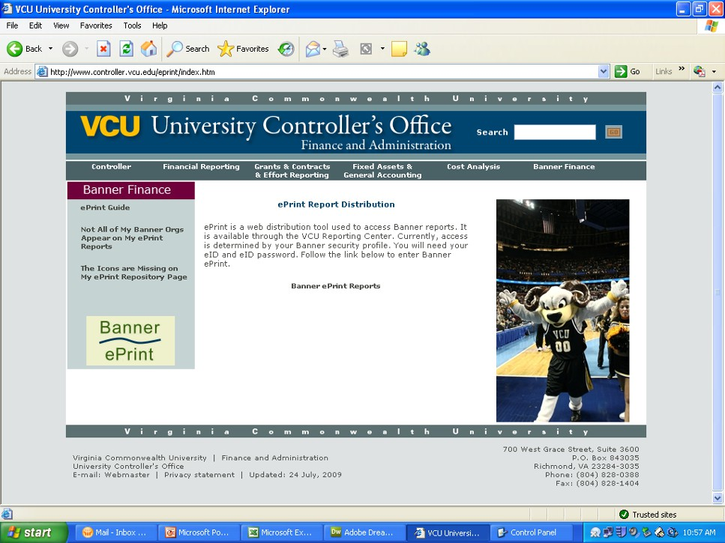
Logging into ePrint

Go to our ePrint home page at
https://controller.vcu.edu/banner-finance/banner-eprint-reports

4

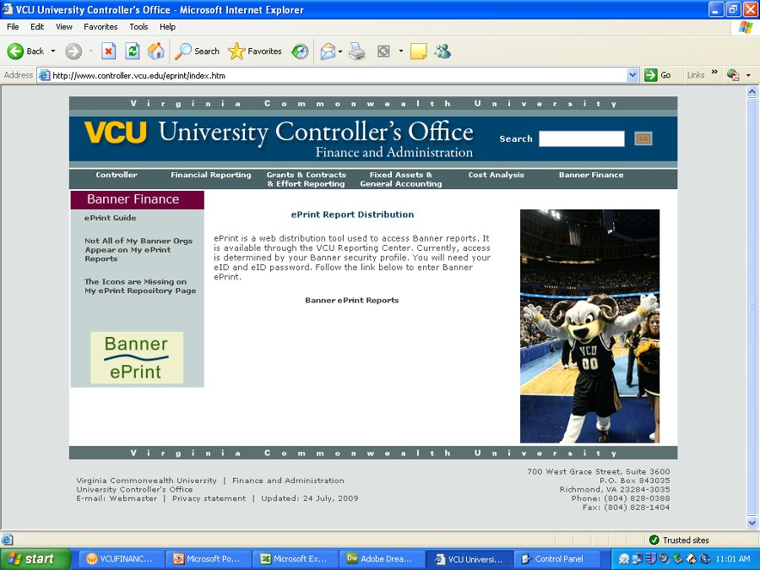
Logging into ePrint

Click on “Banner ePrint Reports”.

5

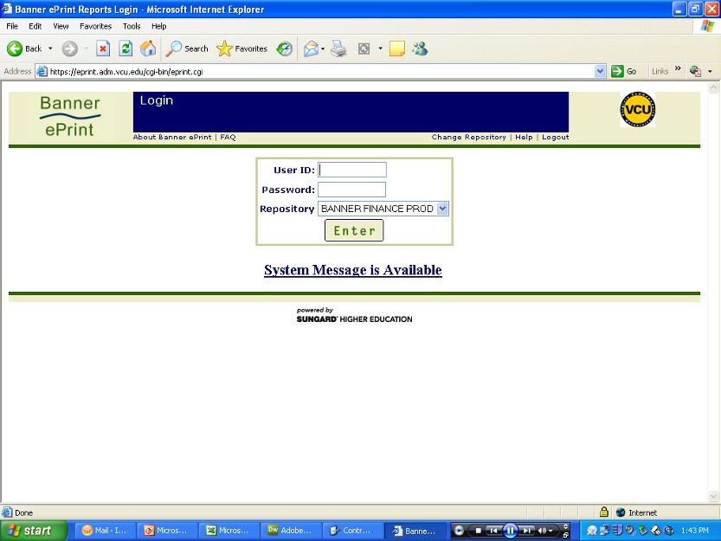
Logging into ePrint

Log-in to ePrint using your eID and eID password.

6

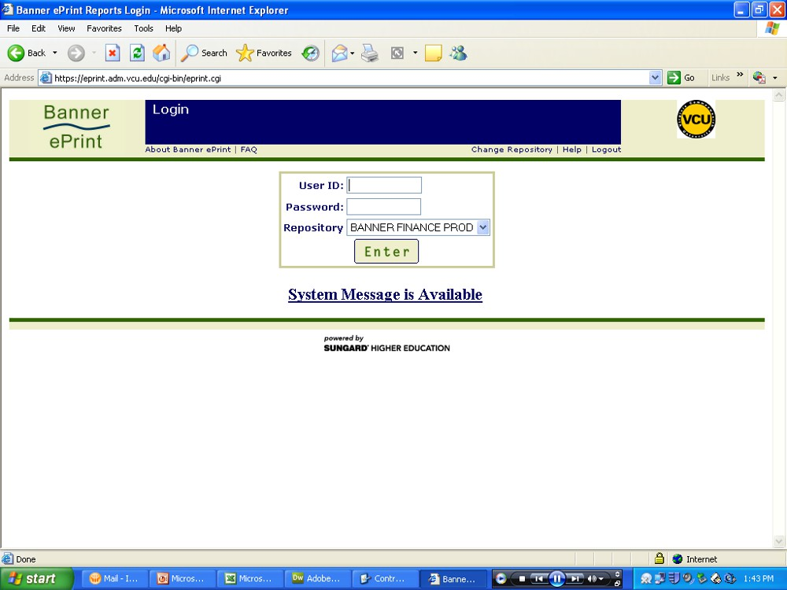
Logging into ePrint

Click on Enter.

7

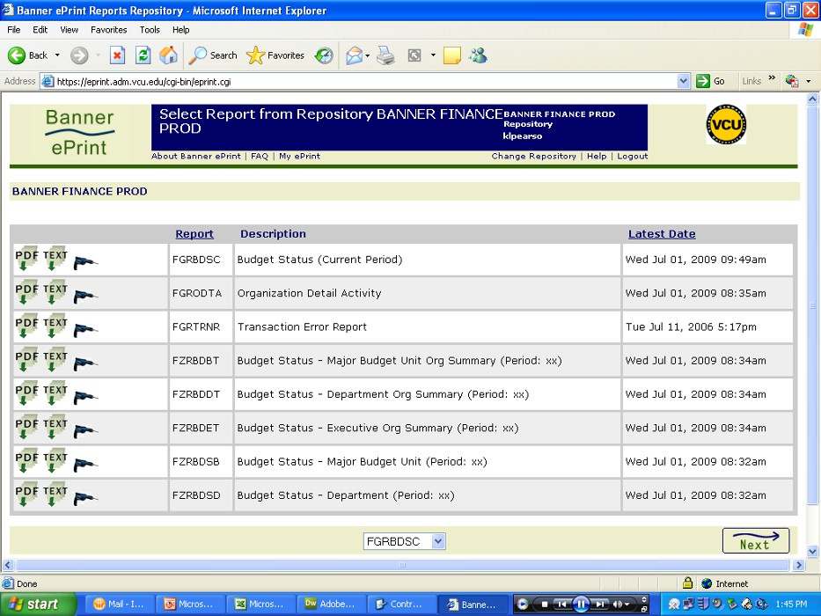
Select Reports

The Report Repository page will display. This page lists the different
reports you have access to view. The “Latest Date” column indicates the last time the report was loaded into ePrint.

8

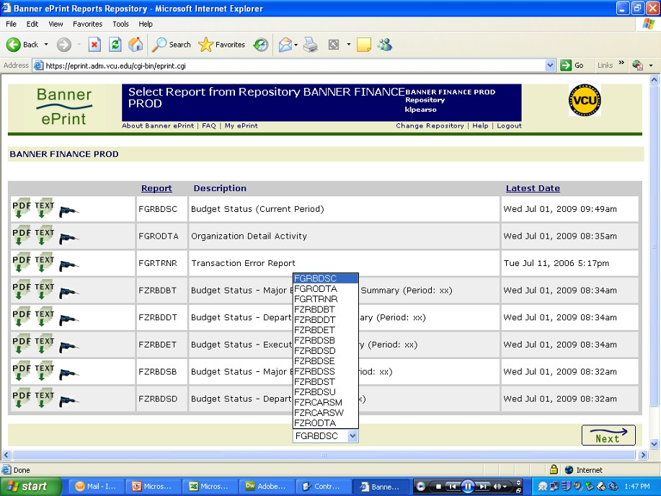
Select Reports

Use the navigational buttons or the drop down menu to select the report you wish to view.

Drop Down Menu

Navigational Buttons
9

Select Reports

There are three options in viewing the reports listed on the Report Repository page.

“PDF” will display, on-line, all Banner orgs available for that report
in the Acrobat Reader®. This option gives you the latest version of the
report.

“TEXT” will open a dialog to download all organizations available for
that report into a text file to use for a Word® or Excel® document. This
option is discussed later in “Saving an ePrint Report as an Excel
Spreadsheet”. This option gives you the latest version of the report.

The “DRILL” will drill-down the report to display a specific org
number(s). This option gives you all archived versions of the report.

10

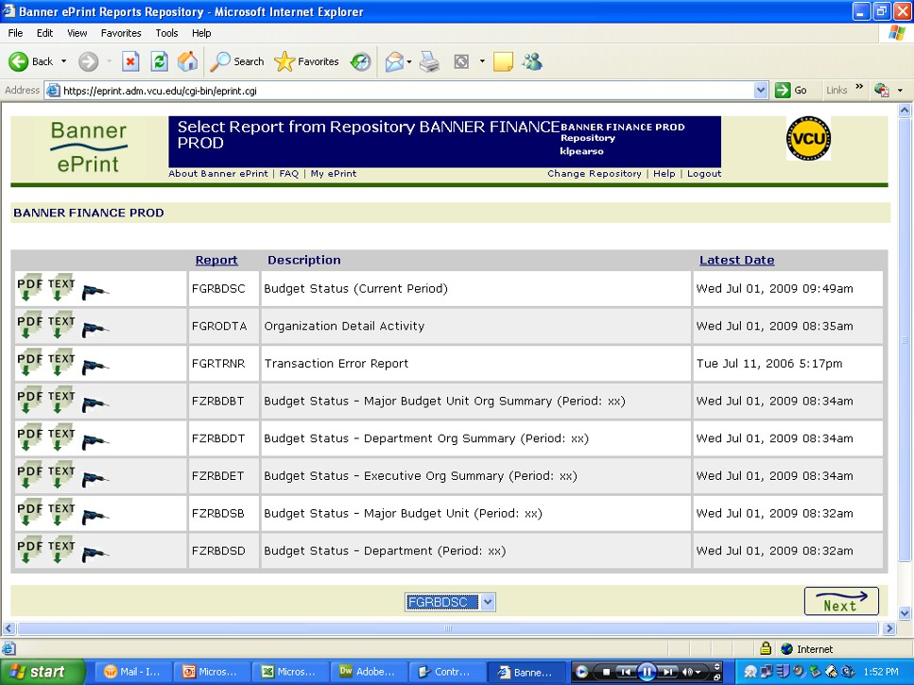
Select Reports

Click on the “PDF” icon

11

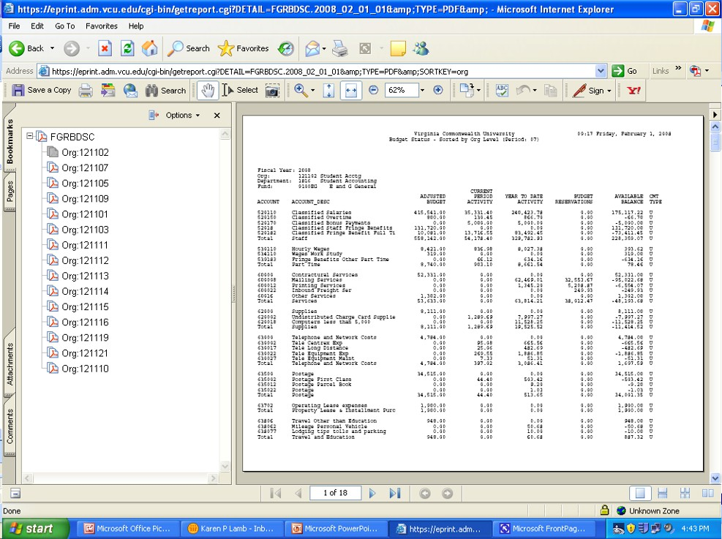
Select Reports
In the left pane, you will see a list of orgs you have access to. The org numbers are used as bookmarks to navigate the report.

12

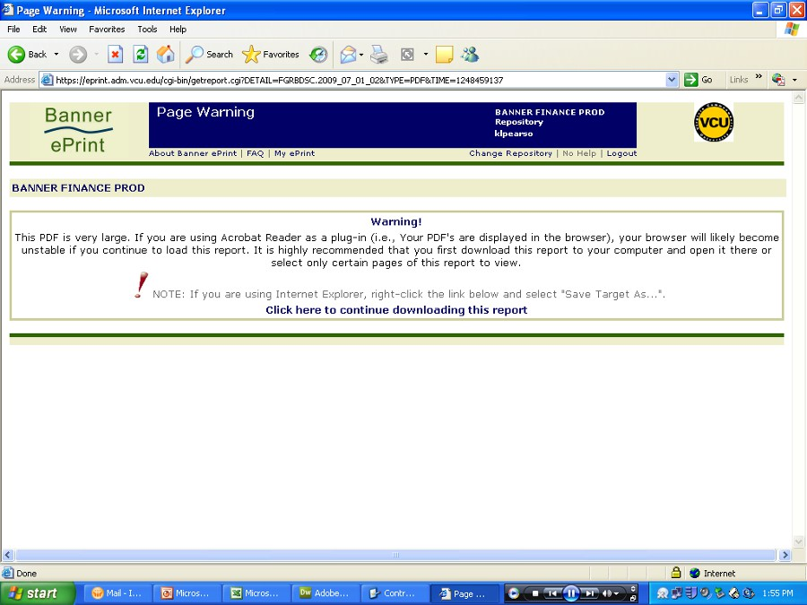
Select Reports
If you receive this message after clicking the “PDF” icon on the
Report Repository page, then the number of orgs included this report is too large to load into the Acrobat Reader®. Click on the Menu bar, Banner Finance Prod, to return to the Reports Repository page.

13

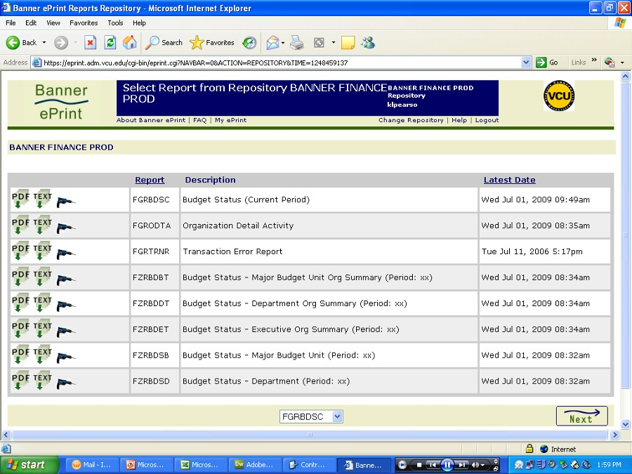
Report Drill Down

Due to the large number of orgs in your report file, you will need to specify an org or range of orgs to view. Click on the Drill Down icon next to the report you want to view.

14

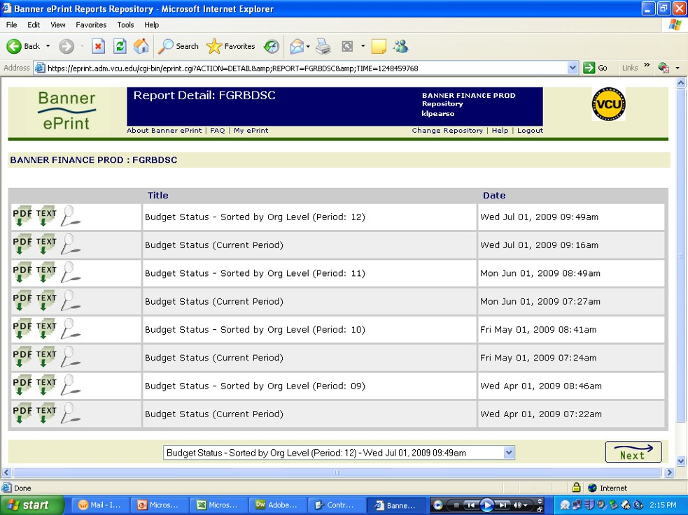
Report Drill Down

The Report Detail page will appear, listing all existing versions of the
report. The most recent report is always at the top of the list. Select the Magnifying Glass icon to limit the report search to specific orgs.

15

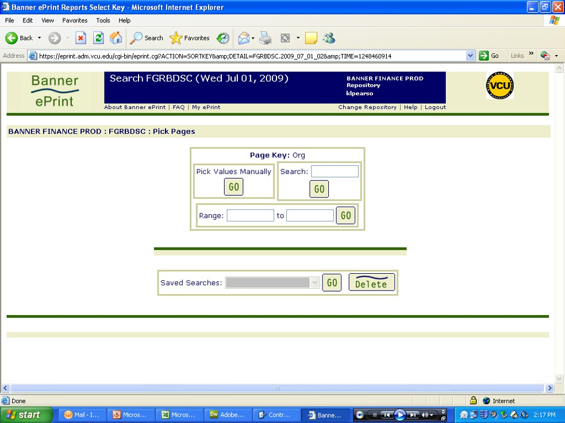
Report Drill Down

The Pick Pages screen will appear. There are three options to limit your
report search to specific 6-digit Banner Orgs under your authority. The first
is the “Pick Values Manually” option. Click to use this option.

16

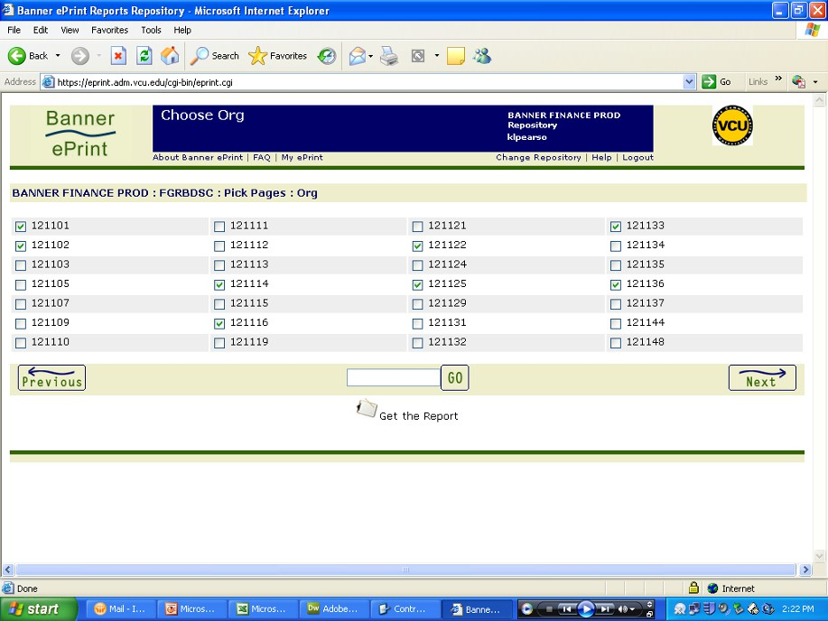
Report Drill Down
You will be provided with a list of all 6-digit orgs within your access (Banner
Security Profile), giving you the ability to click on the orgs you wish to view.
If your list is extensive, use the navigational buttons, to reach all the
number(s). Once all orgs are selected, click the “Get the Report” icon .

17

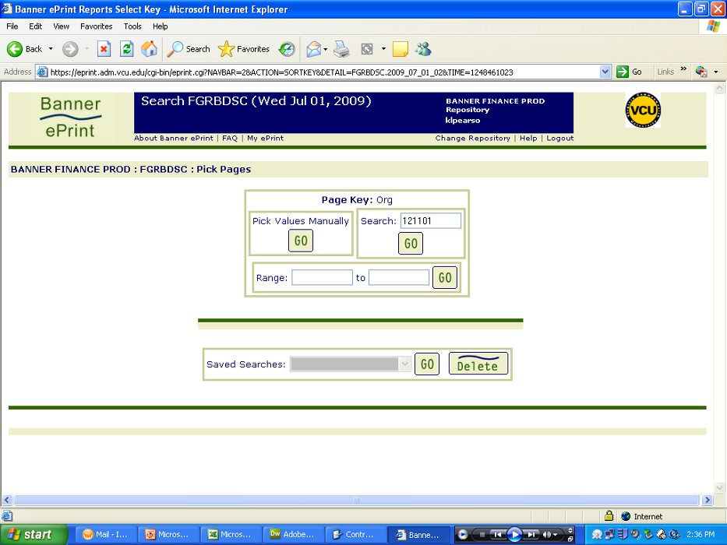
Report Drill Down
The next option for accessing a specific Banner org is “Search”. Under this option, enter the 6-digit org number (no hyphen). Click

18

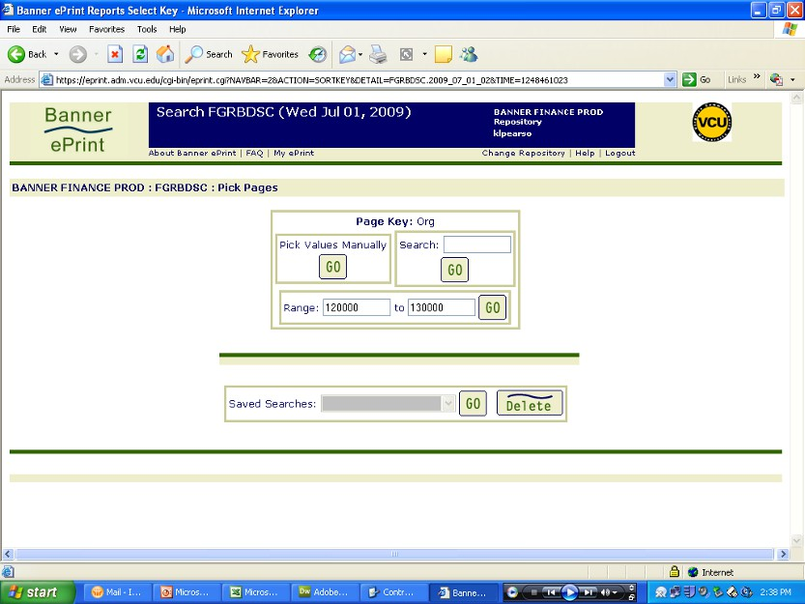
Report Drill Down
The third option allows you to enter a range of orgs to view. A sample of an organization range appears below.

Enter Org Range Here

19

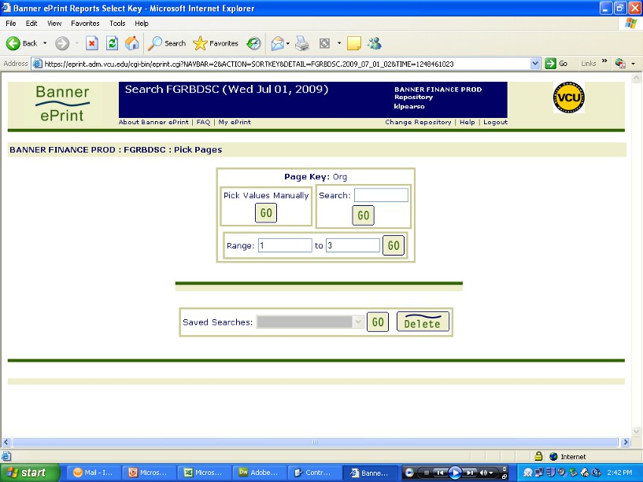
Report Drill Down
The range can also be the first digit of an org, which represents the ledger number, as in this example. After entering the range, click .

Enter Ledger Numbers
Here
20

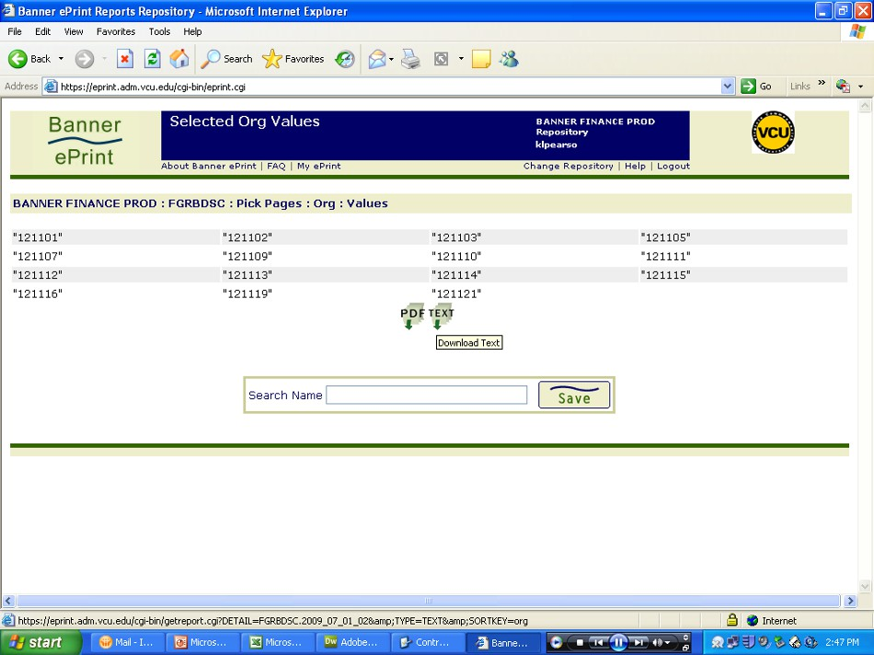
Report Drill Down
The Selected Org Values screen will appear. This screen confirms the
6-digit org numbers you have selected for report display. If these particular orgs are viewed on a monthly basis, you should save this list. See the next page, to learn how.

21

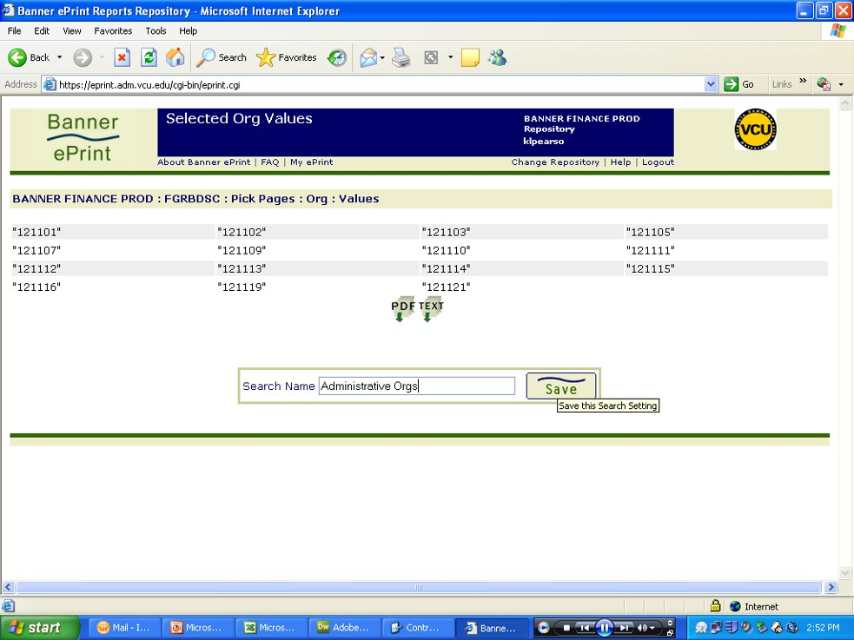
Saving Pick Pages Searches

Type in a name for this search and click save.

22

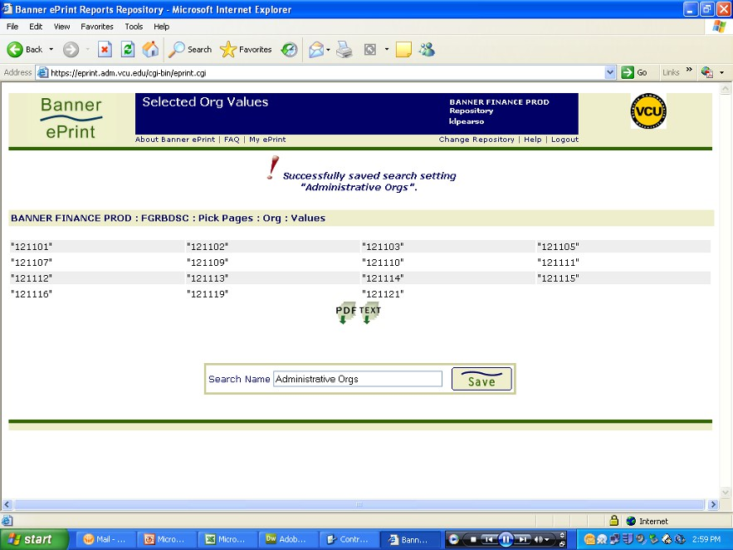
Saving Pick Pages Searches

You will receive a message that your search is saved.

23

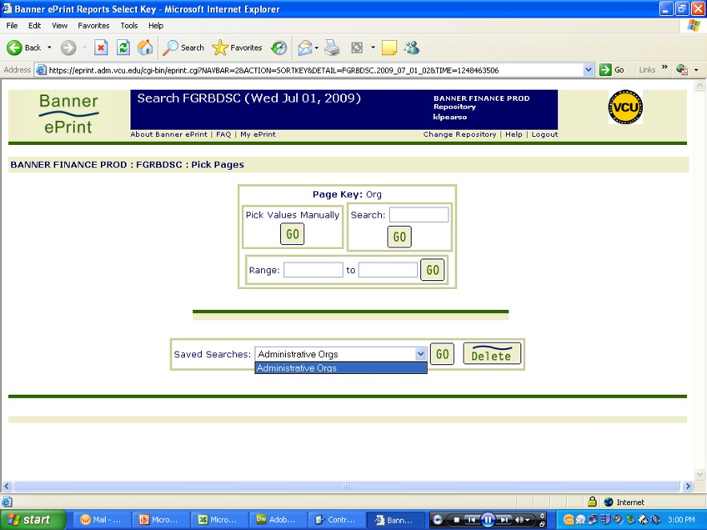
Saving Pick Pages Searches

Now that your search is saved, you can go directly to this saved group from
the Pick Pages menu. Just use the drop down menu for Saved Searches and
click

24

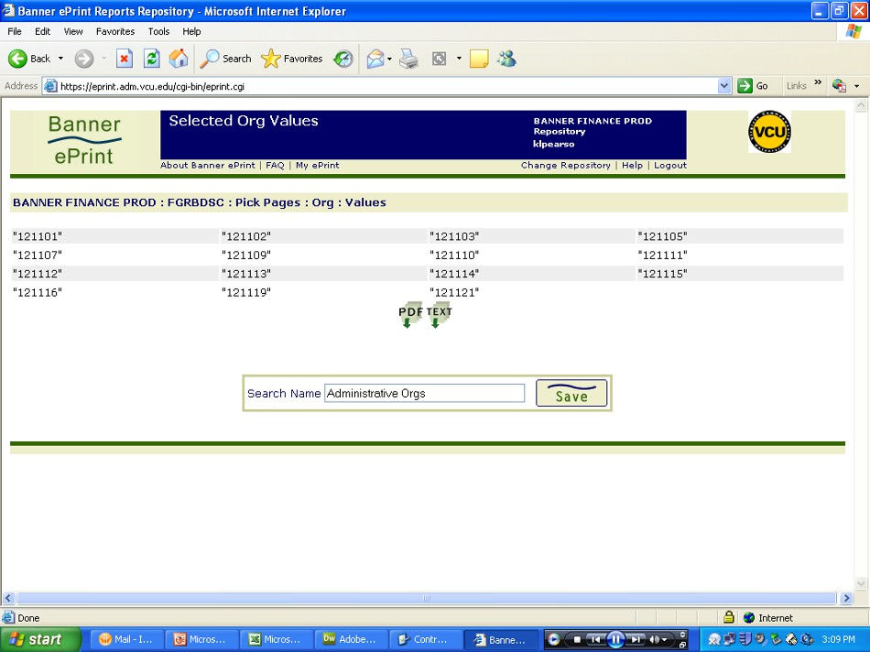
Navigating ePrint

If you want to change the org selection or return to the listing of reports, the navigation bar is more efficient to use than the Back Arrow button on your browser. With the navigation bar, you can pick pages, select accounts or return to the report listing.

Navigation Bar 25

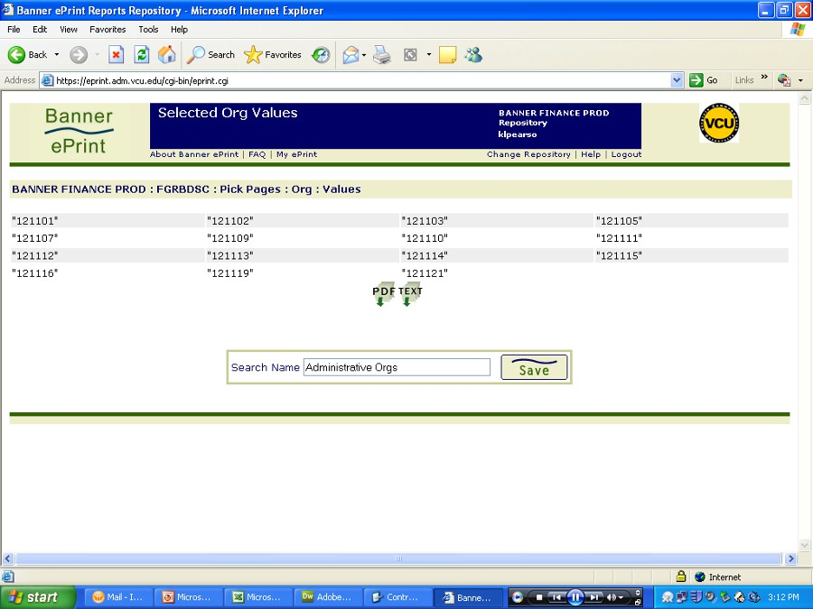
Navigating ePrint

Every page of ePrint (even the Login page) has a link to context-sensitive Help. Every Help Page has a link to a Contents Page, Alphabetized Index and Related Topics.

ePrint Help
26

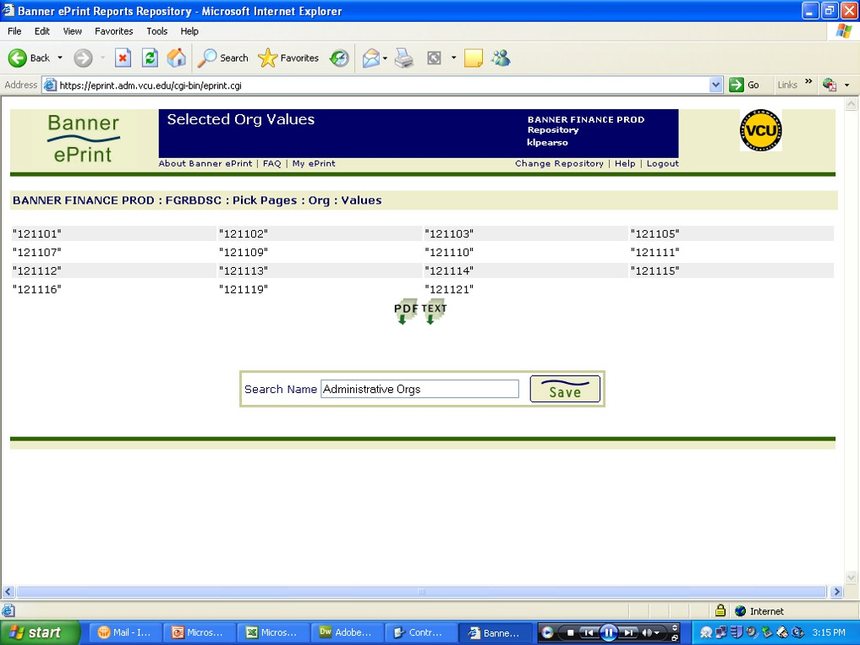
Viewing ePrint Reports

Now you are ready to view your report(s). Click on the “PDF” icon .

27

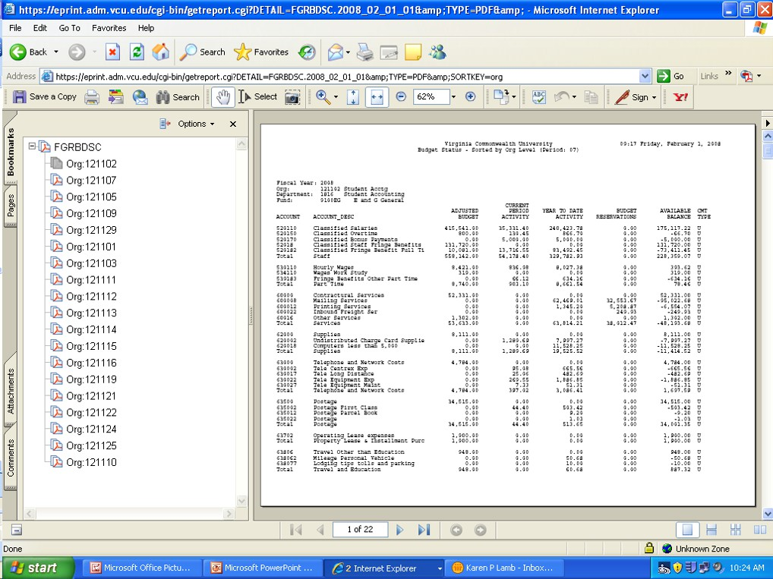
Viewing ePrint Reports
The report will appear in Adobe Acrobat Reader®. Individual orgs will be listed in the left navigation pane.

Acrobat
Navigation
Pane

28

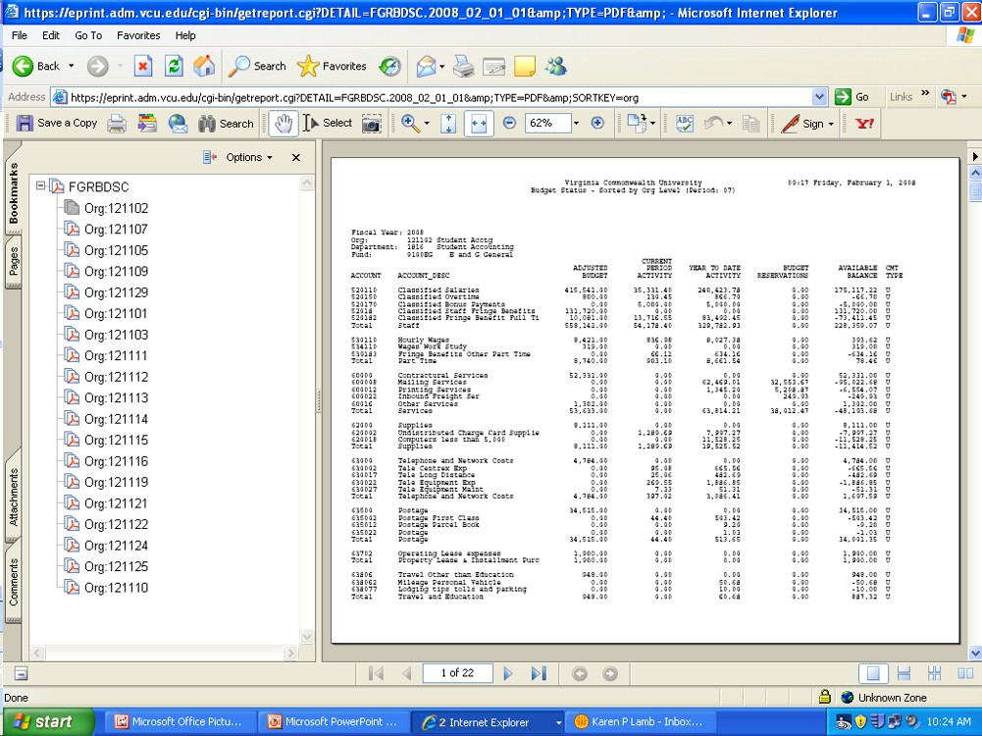
Viewing ePrint Reports
Use the Acrobat® Reader’s Toolbar to navigate and adjust the view of the report.

Acrobat Toolbar

29

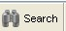
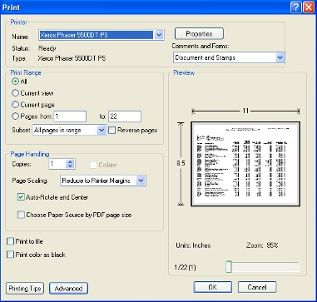
Viewing ePrint Reports

The most commonly used toolbar icons for viewing ePrint reports.

Increases the report display size.
Use these icons to move through the pages of the report.
These icons increase/decrease the report display size.
Search/Search Again to find specific text in the report.
Prints report pages to your printer. Use with Caution! ePrint
will print the total number of pages listed on the toolbar at
the bottom of the screen. To avoid large printing errors,
review and adjust the number of pages selected to print.

Check Page
Numbers Here

30

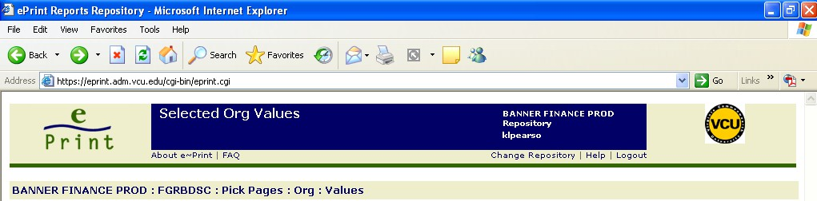
Returning to eprint from the Acrobat Reader®

Use your browser’s back button to return to ePrint and select another report to

view
or logout of e~Print.

Logout Here

31

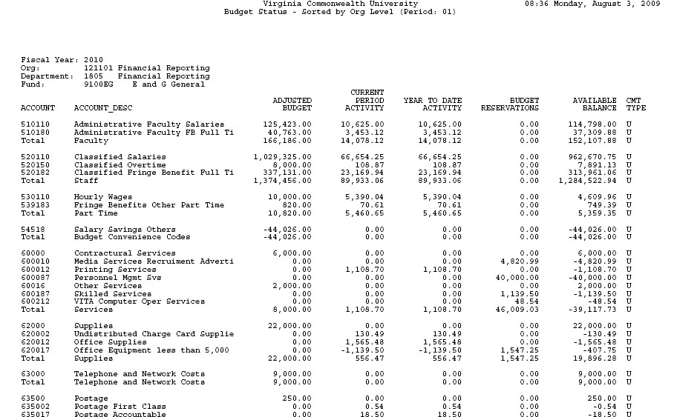
How to read ePrint Reports

The org number and fiscal year are located at the top left. The Account
column is the Banner account used for budgeting and expenditure.
Account_Desc column gives a brief description of the budget/expenditures account.

32

How to read ePrint Reports
Adjusted Budget is your expenditure authority. It is the sum of the original budget, loaded at the beginning of the fiscal year, plus or minus any budget adjustments made since. Budget is loaded by account and subtotaled by
the type of expense (i.e., Staff).

33

How to read ePrint Reports
Current Period Activity is the total monthly expenditures for each account. Year to Date Activity is the total year to date (cumulative) expenditures for each account.

34

How to read ePrint Reports
Budget Reservations are outstanding commitments (encumbrances or purchase orders) that reduce your Available Balance.

35

How to read ePrint Reports
The Available Balance is the sum of all columns per account: Adjusted Budget minus Year to Date Activity (expenditures) minus Budget
Reservations equal Available Balance.

36

How to read ePrint Reports

CMT Type is a field we do not use at VCU. Ignore this column.

37

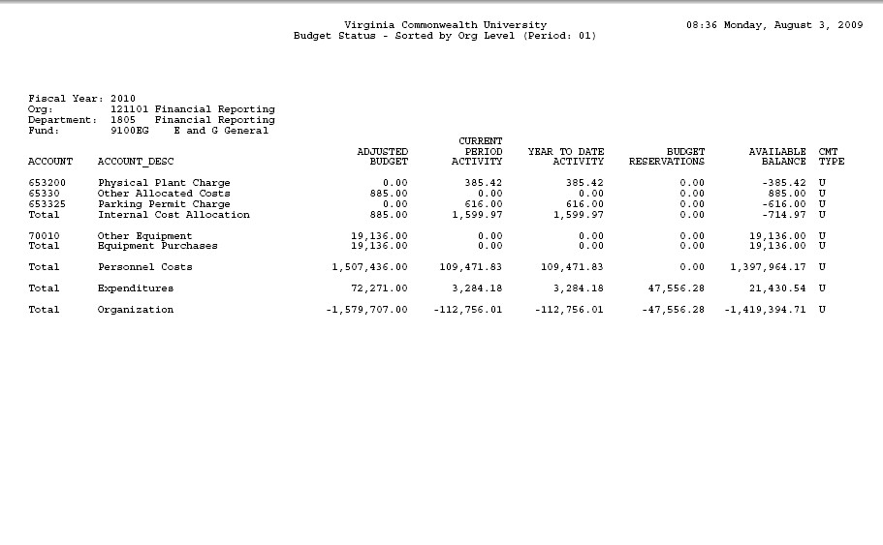
How to read ePrint Reports
The last page gives you totals for the organization by Personnel Costs and other Expenditures. You’ll notice, on this particular org, that the
Organization totals are negative numbers. By default, Banner calculates an organization’s revenues minus its expenditures.

3

How to read ePrint Reports
This particular org does not earn revenues, its expenditure authority is
limited to budget. The totals appear as negative numbers even though
there is budget available. You will need to pay attention to whether an org
is budget or revenue supported in order to properly interpret the report
totals.

3

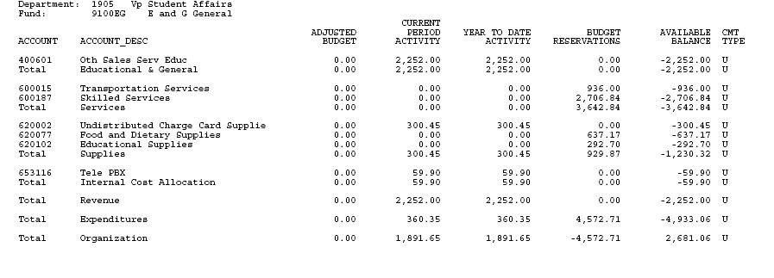
How to read ePrint Reports
This is an example of an organization that earns revenues. You’ll notice
that the org is not budgeted and the revenues and expenditures appear as positive numbers. In this case, revenues minus expenditures equal the Available Balance.

40

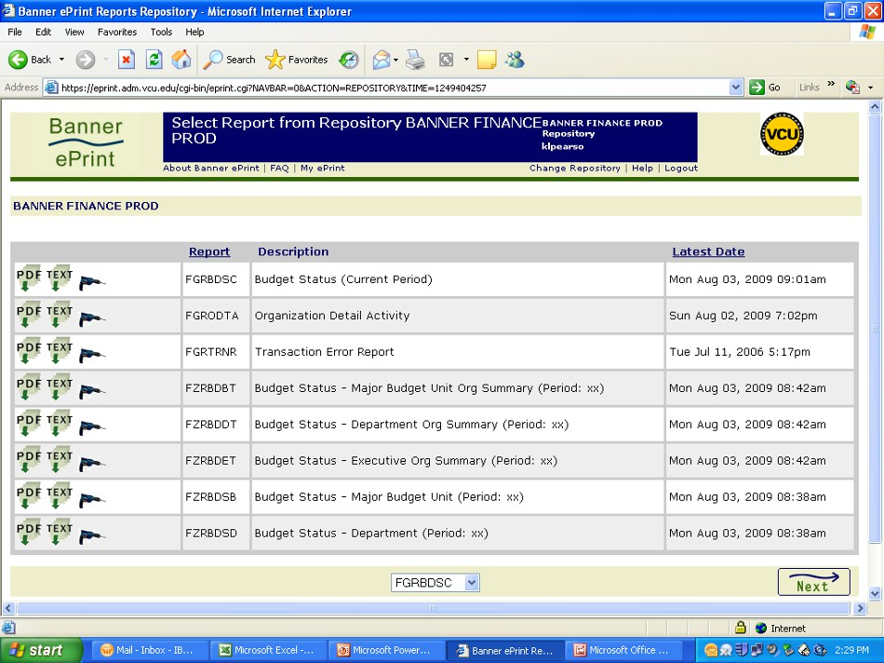
Configuring My ePrint

Another feature of ePrint is the ability to customize your view of the
Report Repository page. On the Report Repository Page (Banner Finance Prod) you’ll see a link called My ePrint.

41

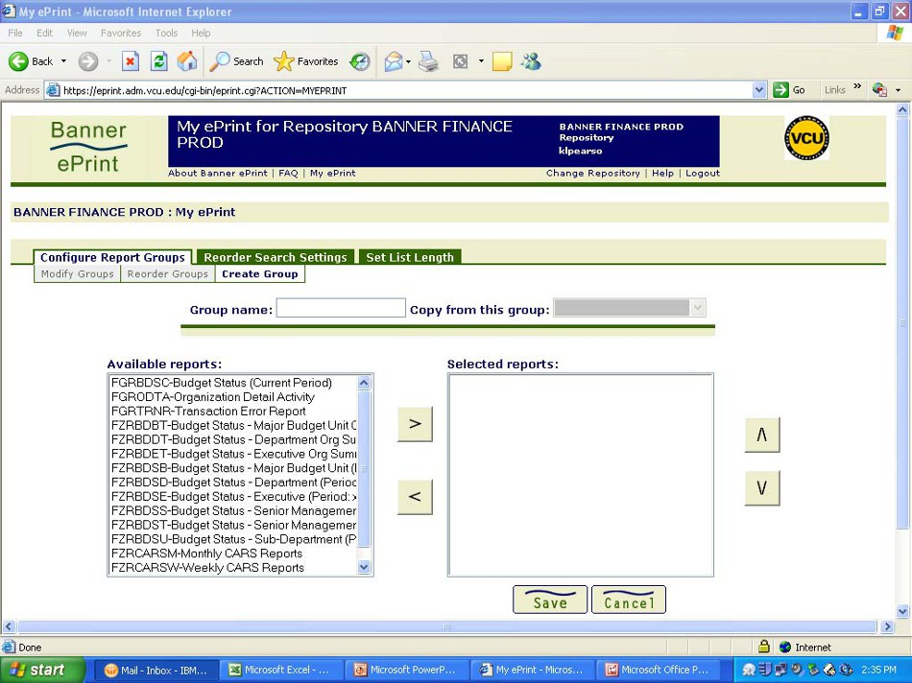
Configuring My ePrint

If you click on the link, you enter the Create Group dialog. From here you
can create a group of reports that you run regularly and give them a name. For our example, we’ll create a group called “Budget Reports”.

42

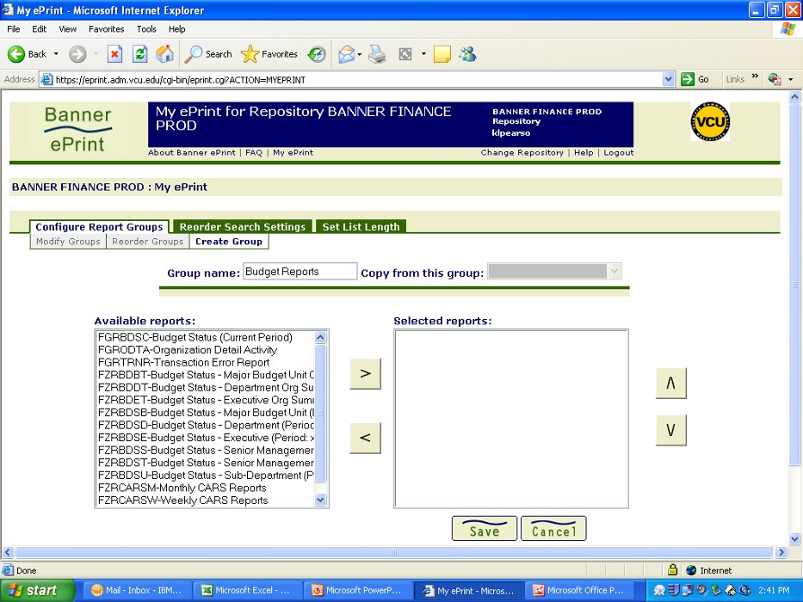
Configuring My ePrint

First, give the group a name. Type in the box, Group name.

43

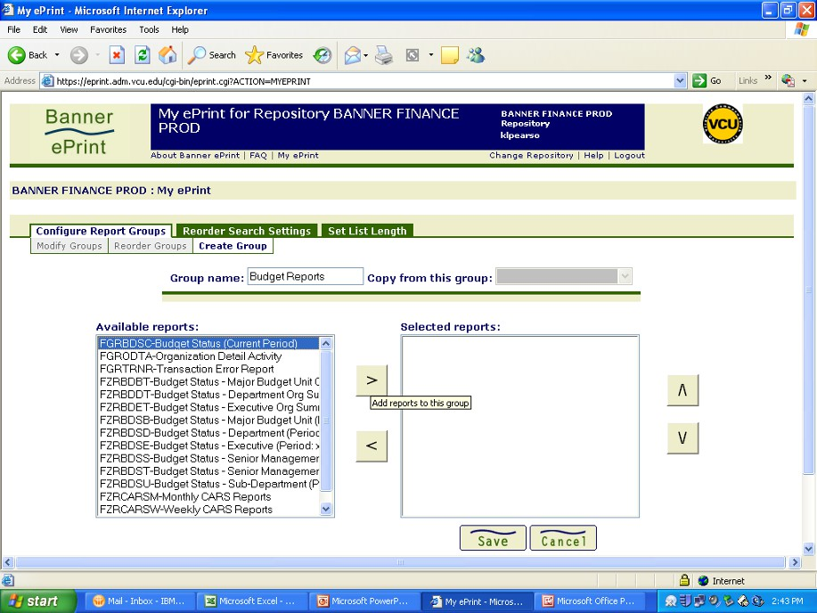
Configuring My ePrint

Next, select the reports you want in this group by clicking on the report
name in the left side box called Available Reports. Click on the arrow
button, >, to add the report to the right side box called Selected reports.

44

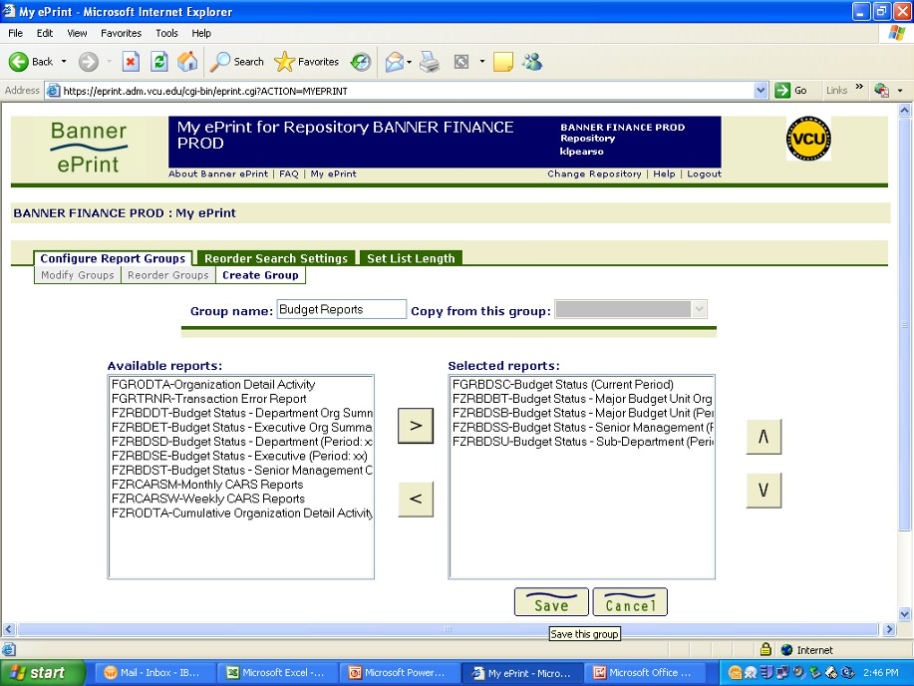
Configuring My ePrint

When you are finished selecting, click on the save button to save the group.

45

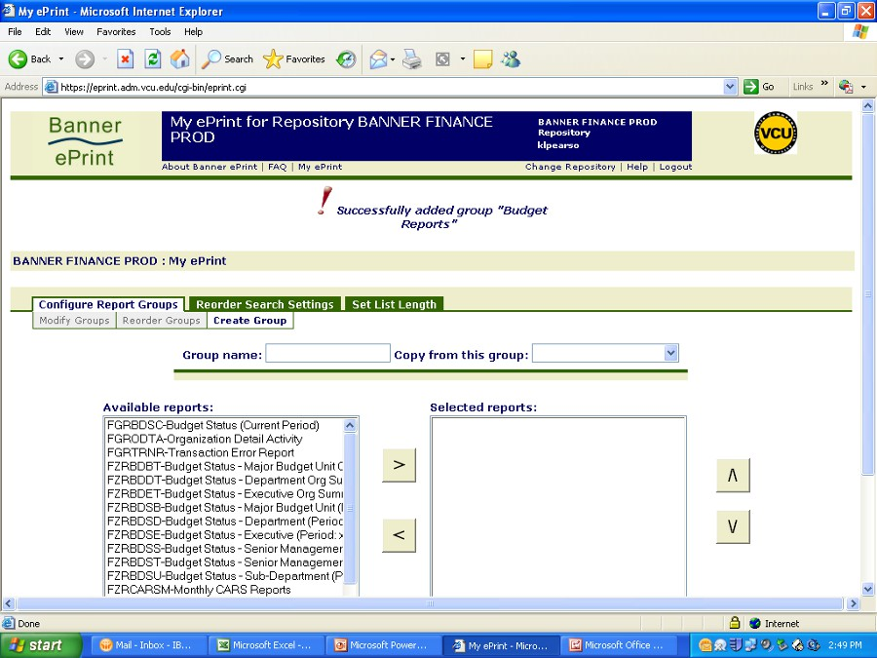
Configuring My ePrint

You will receive a successfully added message. Now click on Banner Finance Prod on the menu bar.

46

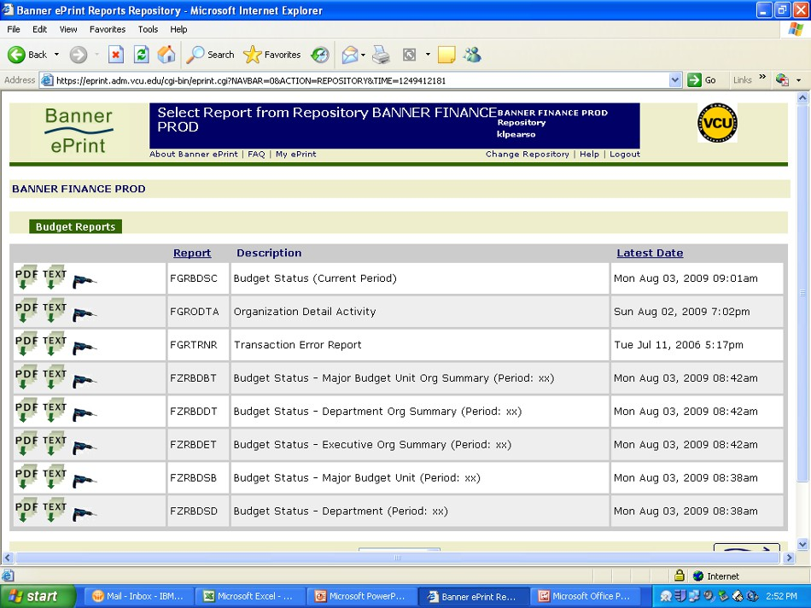
Configuring My ePrint

Now, on the Report Repository page, you will see a tab for the reports you have selected to be in the this group. Click on the tab.

47

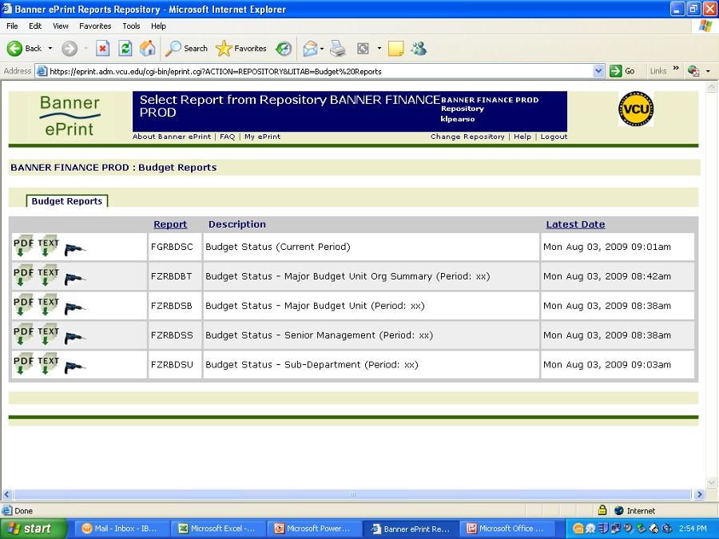
Configuring My ePrint

Only the reports in this group will be shown. My ePrint is good way to
organize your report views and separate budget reports from transaction reports.

48

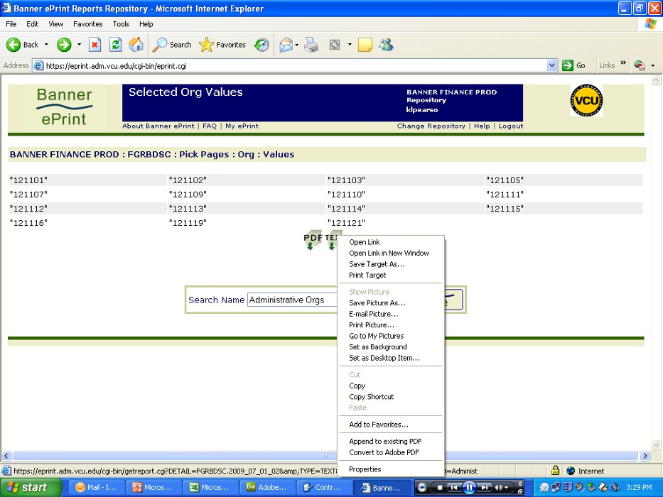
Saving an ePrint Report as an Excel Spreadsheet
Next, we’ll learn how to save an ePrint Text file as an Excel spreadsheet. Right click on the “TEXT” icon after selecting which orgs to view.

49

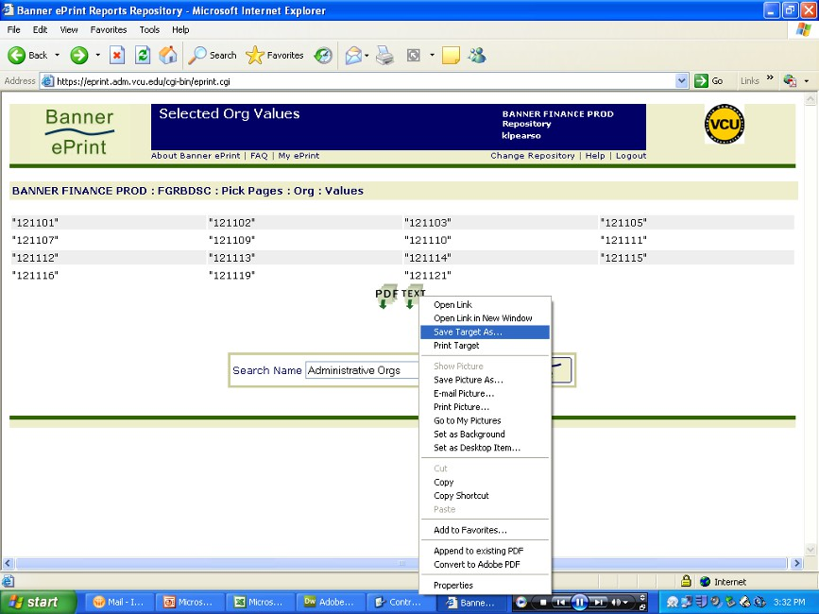
Saving an ePrint Report as an Excel Spreadsheet

Select “Save Target As”.

50

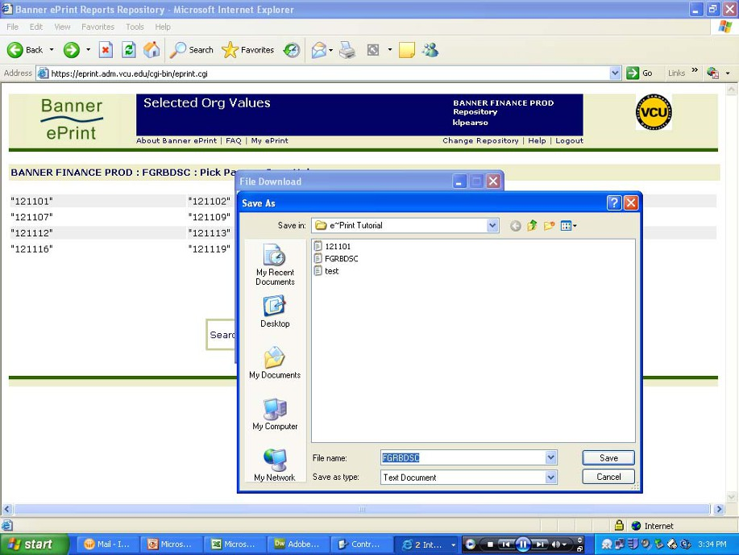
Saving an ePrint Report as an Excel Spreadsheet
Select a location on your pc to save the file. Click “Save”. You can also rename the file.

51

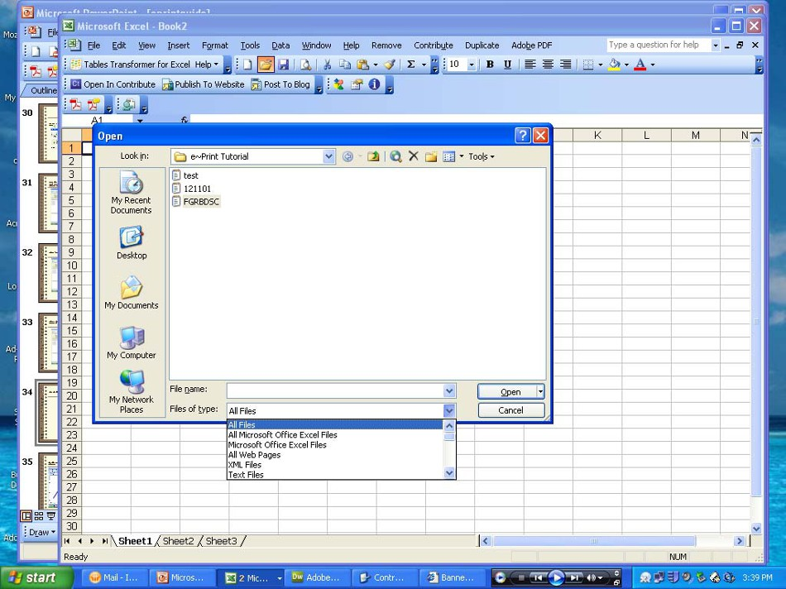
Working with Text Files
Open the file in Microsoft Excel®. You will find it under the All Files option. It will have a .txt extension. Click “Open”.

52

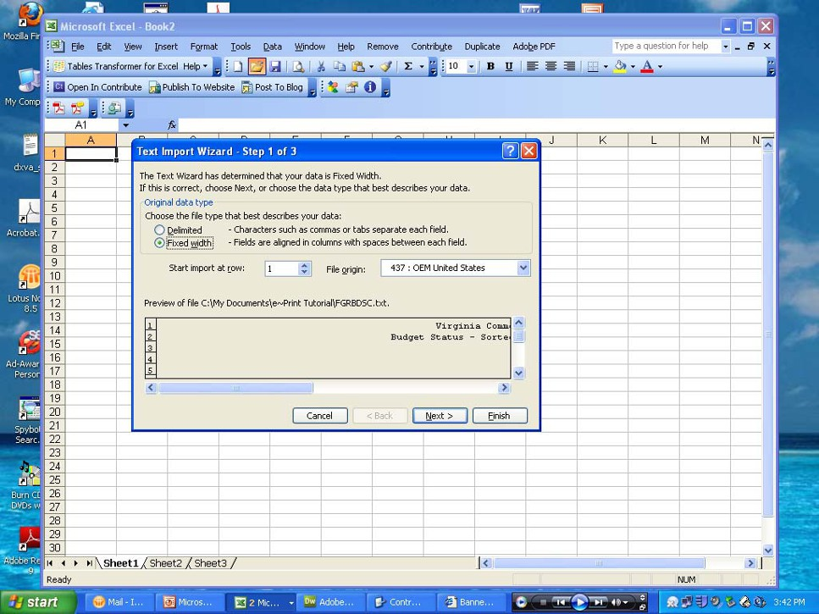
Working with Text Files
The File Conversion Wizard will appear. Since ePrint reports have columns, you can choose Fixed Width and click on Next.

53

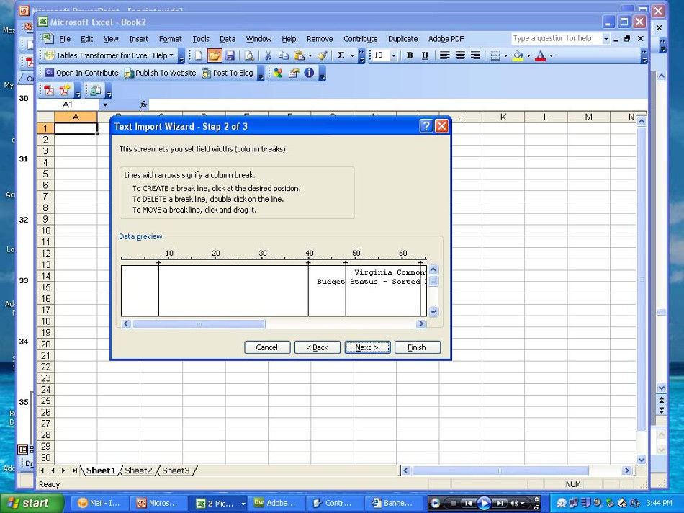
Working with Text Files

This screen gives you the opportunity to set your column widths. You can also do this later, after the file has converted. Click Next.

54

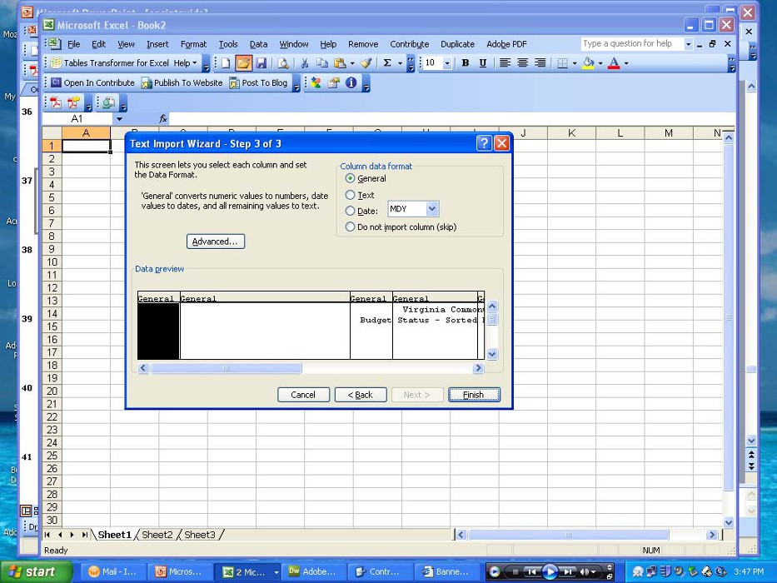
Working with Text Files
This screen prompts you to format the column data. All columns should be General format. Click Finish.

55

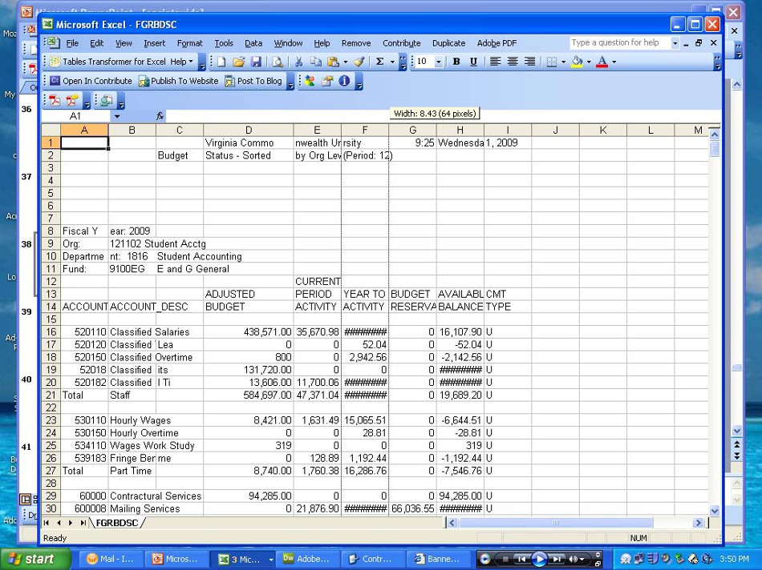
Working with Text Files

Adjust your column widths to accommodate the data. Just click in between
the column letters, hold your mouse button down, and make the columns
larger.

56

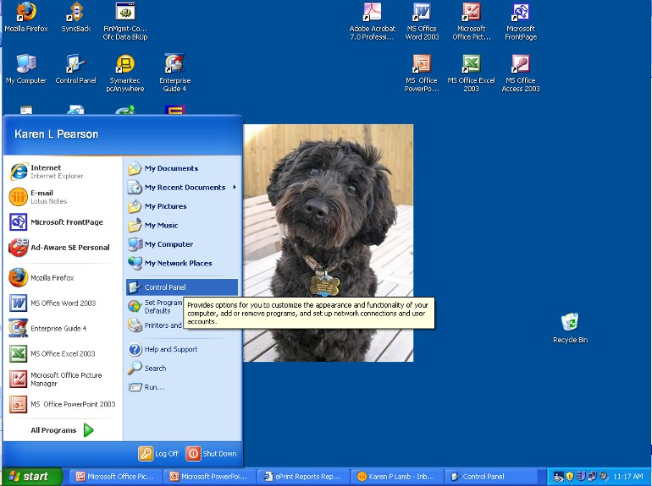
ePrint Technical Troubleshooting

1. My report display area is extremely small or I am having problems displaying reports.
A popular windows desktop setting related to displaying ePrint reports is
1024X768 pixels. This setting can be set by clicking Start>Control Panel on your Windows® desktop.

57

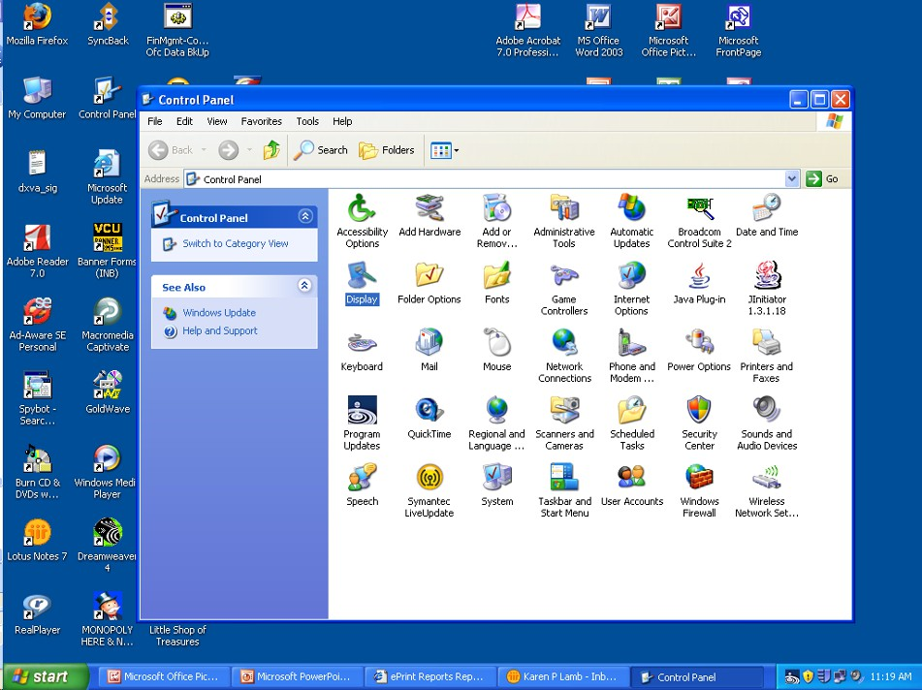
ePrint Technical Troubleshooting

Select “Display”.

58

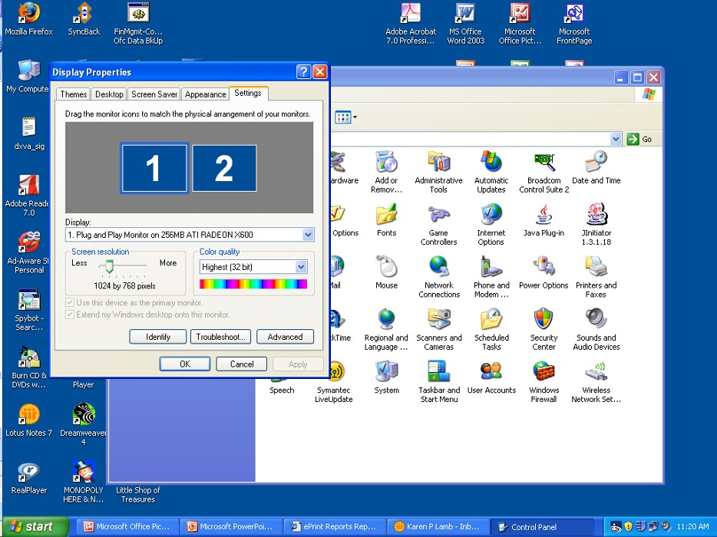
ePrint Technical Troubleshooting

Select the “Settings” tab and move the arrow under “Screen Resolution” until 1024X768 is displayed.

59

ePrint Technical Troubleshooting

2. I am using Microsoft Internet Explorer® and when I try to retrieve a PDF file (report) sometimes the window appears blank.
If this happens, trying clicking the Refresh button on the browser’s toolbar.

3. I do not have access to the proper 6-digit org numbers.
Contact the Banner Finance Security Team at finsecurity@vcu.edu or call
8-0388 for the Banner Finance Help Desk.

4. When I view reports on-line through Acrobat Reader® the screen jumps as I move to additional pages.
Smoother page transition is accomplished by setting the change display
layout to continuous. This option is located on the bottom toolbar of the Acrobat Reader®.

60

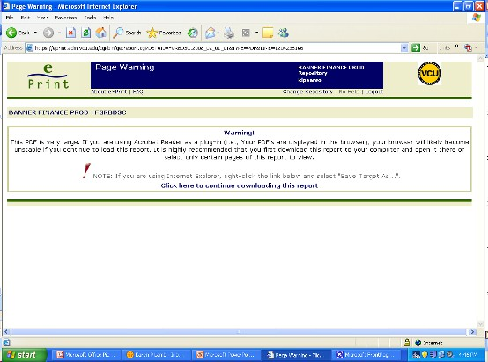
ePrint Technical Troubleshooting

5. I get the following error message when I try to bring my reports up in the Acrobat Reader®.

Individuals with access to hundreds of 6-digit orgs may encounter this error message. If you receive this error, you need to use the drill down icon to limit the number of accounts you load into your Acrobat Reader®.

61

ePrint Technical Troubleshooting

6. I am using Microsoft Internet Explorer® and some of the icons on the report repository page are missing.

The Reporting Center uses a Secured Socket Layer (SSL) that requires a
128 bit encryption on your browser. Check your browser version by selecting
Help>About Internet Explorer. Check the Cipher Strength to see if it is 128-bit.
If it is not, you will need to download a newer version of Explorer® from
http://www.ts.vcu.edu/fq/software/.

62

