Banner Index Codes
▪Many Banner forms use the Banner Index field to retrieve and post information. Index codes were developed to save time and ensure that data is accurately entered into
Banner. An Index is the same 6 digit code as a 6 digit organization (org code) and
defaults to a unique combination of Fund, Org (organization), and Program code that
represent part of the FOAPAL in Banner.
▪The Banner FOAPAL can be a complex concept to grasp, but here is a simple way to think of how transactions are organized by the FOAPAL:
▪I made a purchase using this money (FUND) for my department (ORG). I purchased this type of product or service (ACCOUNT) to fulfill this
particular function (PROGRAM).

▪ An index code can be compared to a bank account number. When you provide a
bank with your account number, the bank knows who you are and the routing
number to which account your money is to be deposited or withdrawn. In the
same way, when you provide Banner with an Index code, Banner knows your Org,
and to which Fund and Program your Organization’s money is to be deposited or
withdrawn.
1

Banner Index Codes

Organization Type
Education & General Operating
Qatar Operating Accounts FACR
HEETF
Auxiliary Enterprises
Auxiliary Enterprises
Unrestricted Local
Sponsored Programs
General Fund Appropriations
Service
General Fund Scholarships
Eminent Scholars General Fund
Eminent Scholars Foundation
Pool Accounts Work Study
Restricted Local
Federal Financial Aid
Moving and Relocation Accounts
Agency Fund
Hospital Services
Banner Index/Org Code Range Fund Source
1XXXXX State Funds
HQXXXX State Funds
2XXXXX State Funds
EFTXXX State Funds
31XXXX-35XXXX State Funds
36XXXX-39XXXX Local Funds
4XXXXX Local Funds
5XXXXX State Funds
AXXXXX State Funds
CXXXXX State Funds
FAXXXX State Funds
SAXXXX State Funds
SSXXXX State Funds
TXXXXX State Funds
WXXXXX State Funds
6XXXXX Local Funds
FFXXXX State Funds
PRXXXX State Funds
8XXXXX Agency Funds
H8XXXX State Funds
2

LEDGERS
Banner indexes (org codes) are grouped by type. The first one to three digits
identifies the ledger and type of organization.

State Fund Indexes-Ledgers 1, 2, 3, 5, H8, etc. State rules apply to these
indexes. State regulations prohibit many types of expenses including alcohol,
entertainment, social club memberships, Christmas expenditures, gifts or
donations. Since these funds belong to the Commonwealth, departments are
prohibited from processing expense transfers that charge (debit) a state index and credit a local index.
Local Fund Indexes-Ledgers 3, 4, and 6. In this case, the money in these orgs belongs to the University and is generally earned through gifts, investment income or income on endowments. Local fund indexes have fewer
restrictions on expenditures.
3

LEDGERS

Agency Fund Indexes-Ledger 8. The cash in these orgs belong to student, faculty or other organization. The University has no claim on these funds, but rather acts as the paymaster for these organizations.
4

Accounts in Banner Finance
The Account is a 5 or 6 digit code that identifies the type of activity occurring in a fund or organization.
Activity is identified by the first digit: 1=Asset Accounts for Funds
2=Liability Accounts for Funds
3=Fund Balances and Control Accounts for Funds 4=Revenue Accounts for Organization Codes
5=Labor (salaries, fringe benefits, etc.) Accounts for Organization
Codes
6=Other Cost Accounts (supplies, services, non-labor) for Organization Codes
7=Equipment and Capital Project Construction Accounts for Organization Codes
9=Transfer Accounts for Organization Codes

Banner account 620012, for example identifies a payment,
encumbrance or other transaction for office supplies.
5

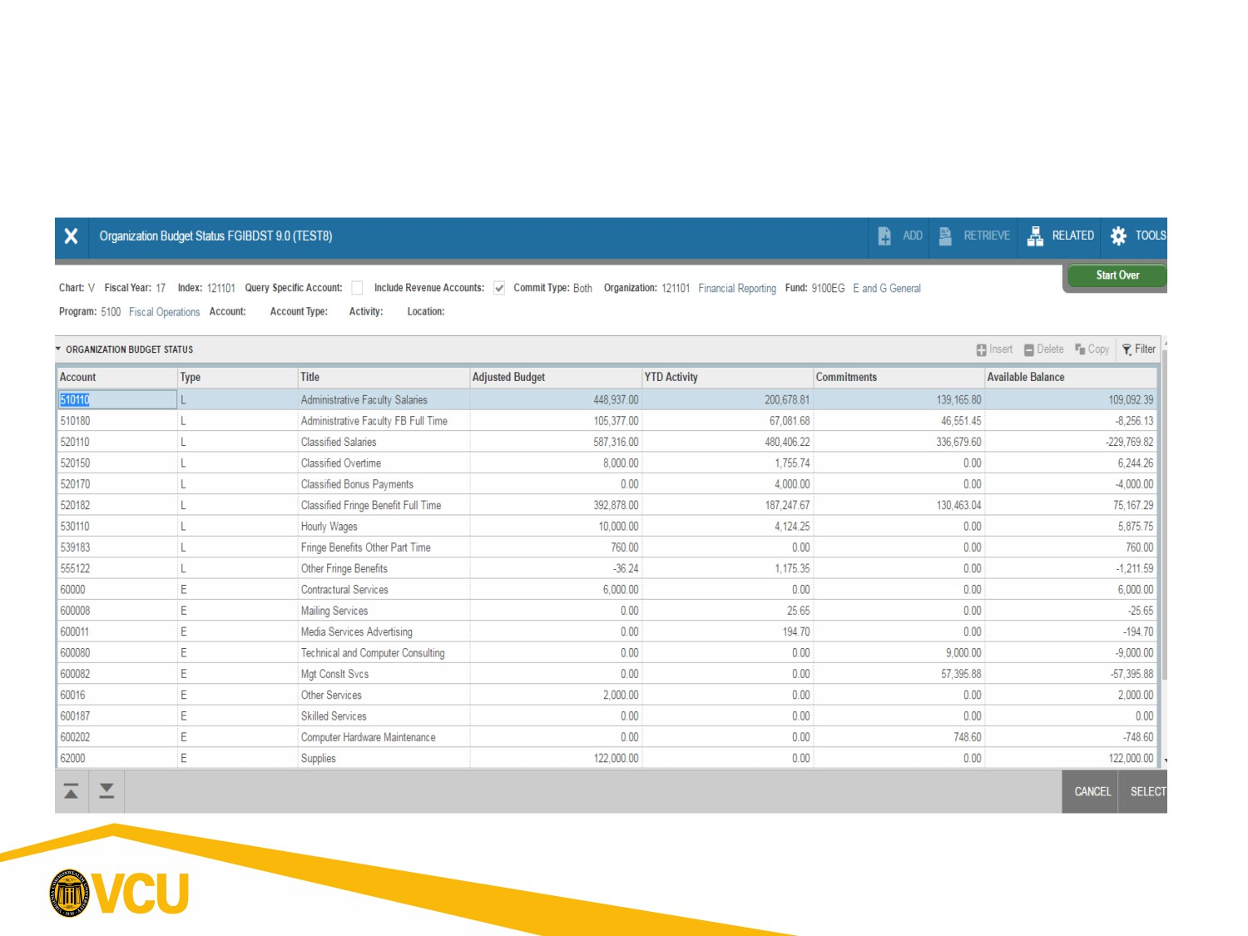
Accounts
Transactions are recorded in 6 digit accounts. Budget is often recorded in 5 digit summary accounts known as Budget Pools. See the example below.
6

