Fixed Asset Policies - Banner Procedures

FFRPROP - Fixed Asset Property Report
The Fixed Asset Custodian must maintain all of the fixed asset
information in Banner that is assigned to them.

This report is available in production Banner XE. Use this report
to verify fixed assets assigned to a specific fixed asset
custodian.

• A FC number is assigned to all fixed assets in Banner.
1

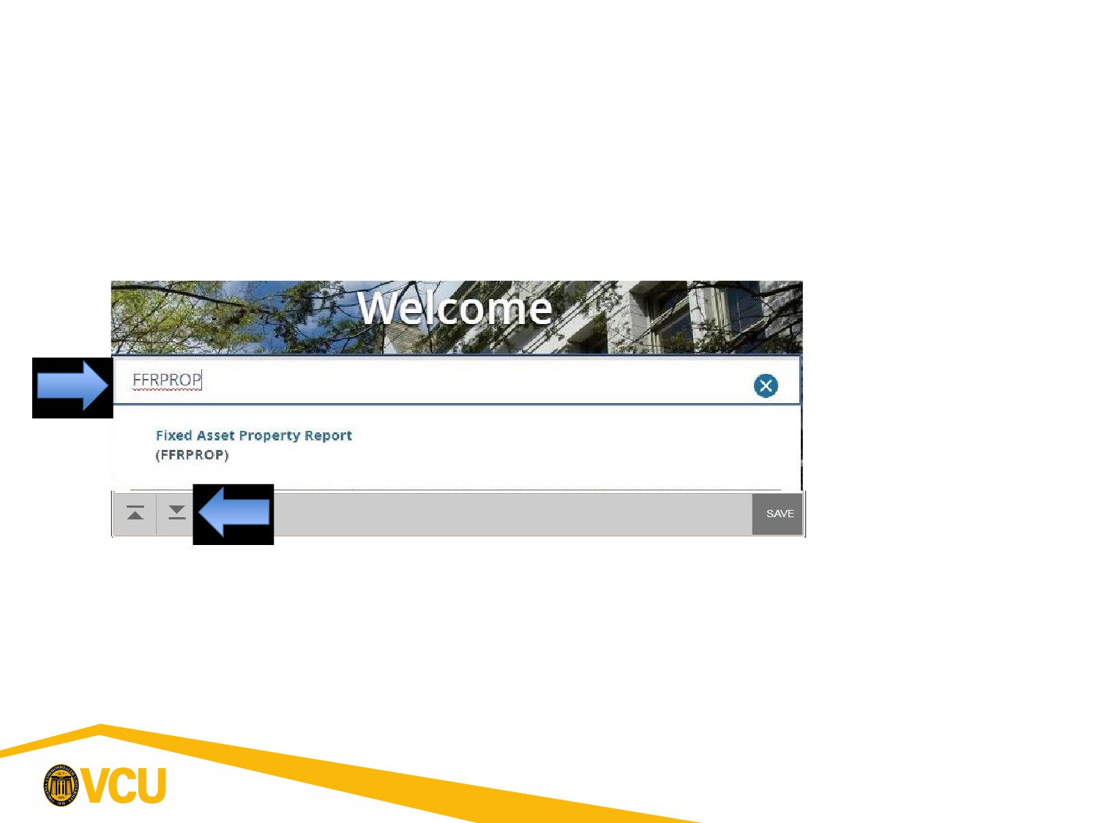
Fixed Asset Policies - Banner Procedures

• How do I Run a Property Report in Banner 9?
• Type FFRPROP in the Search Box:
• Click on the Next Block icon.
2

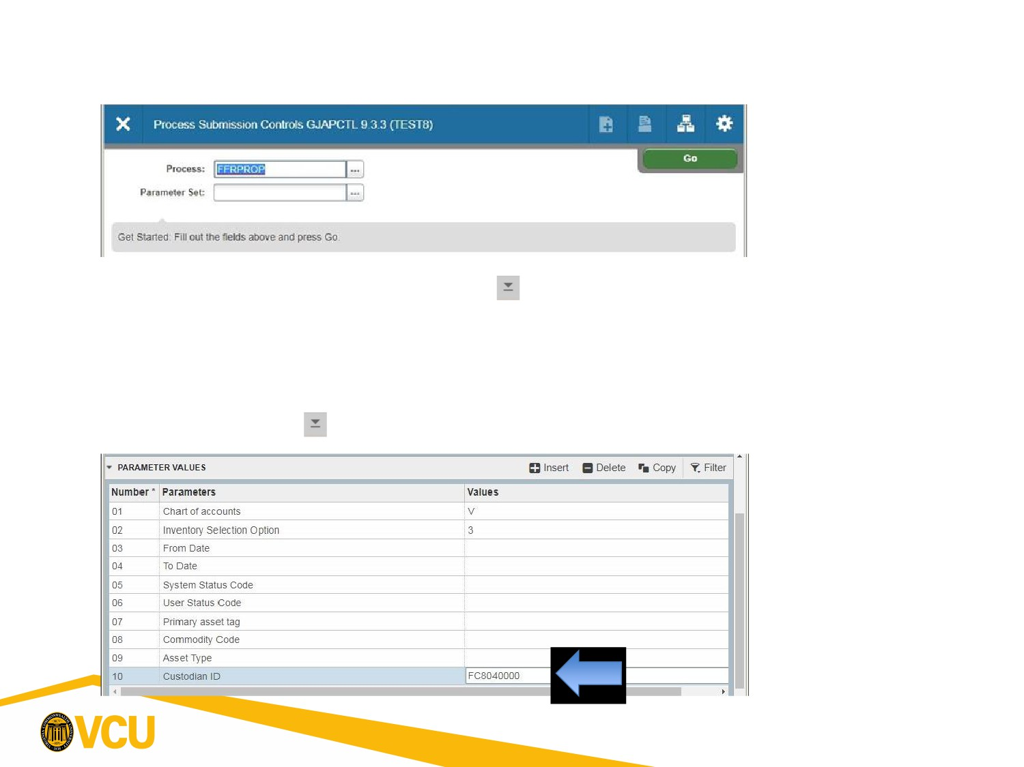
Fixed Asset Policies - Banner Procedures

• Click on the Next Block icon again to enter the Parameter
Values block.
• Scroll down to the Custodian ID (Item 10, begins with FC). Click
on Next Block to enter the Submission block.
3

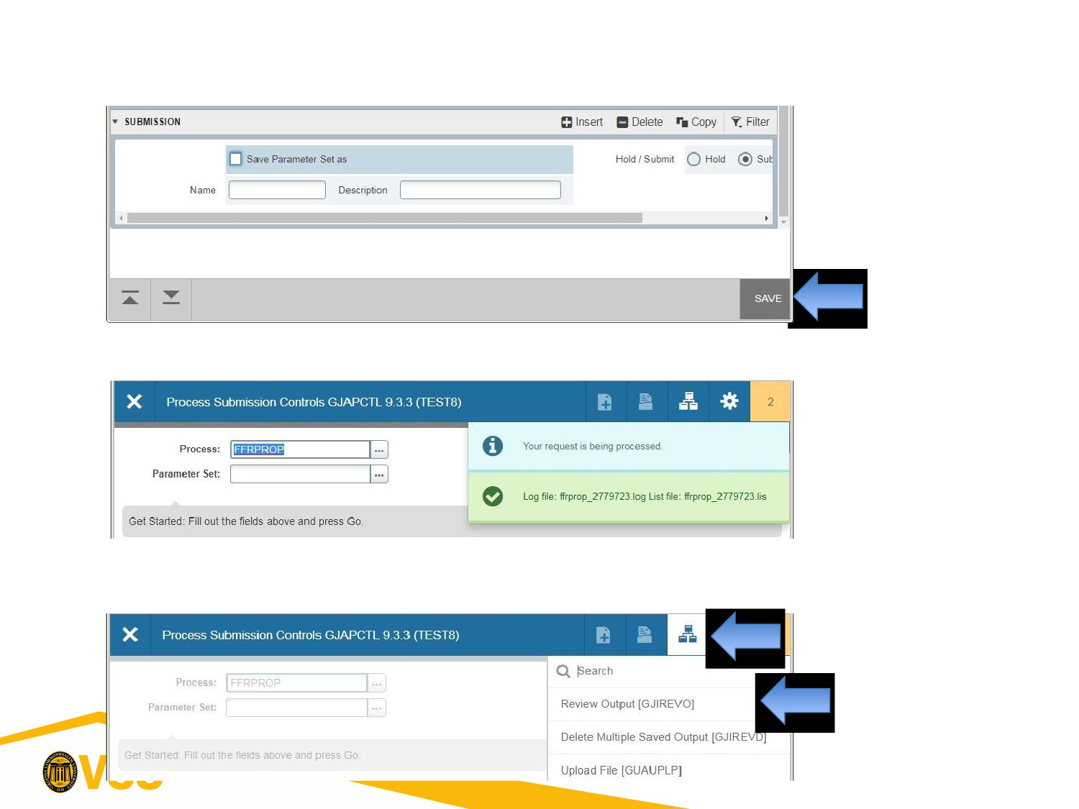
Fixed Asset Policies - Banner Procedures

• Click on the Save icon at the bottom.
(Remember
the Log file #)

• Click on Related icon then Review Output.
4

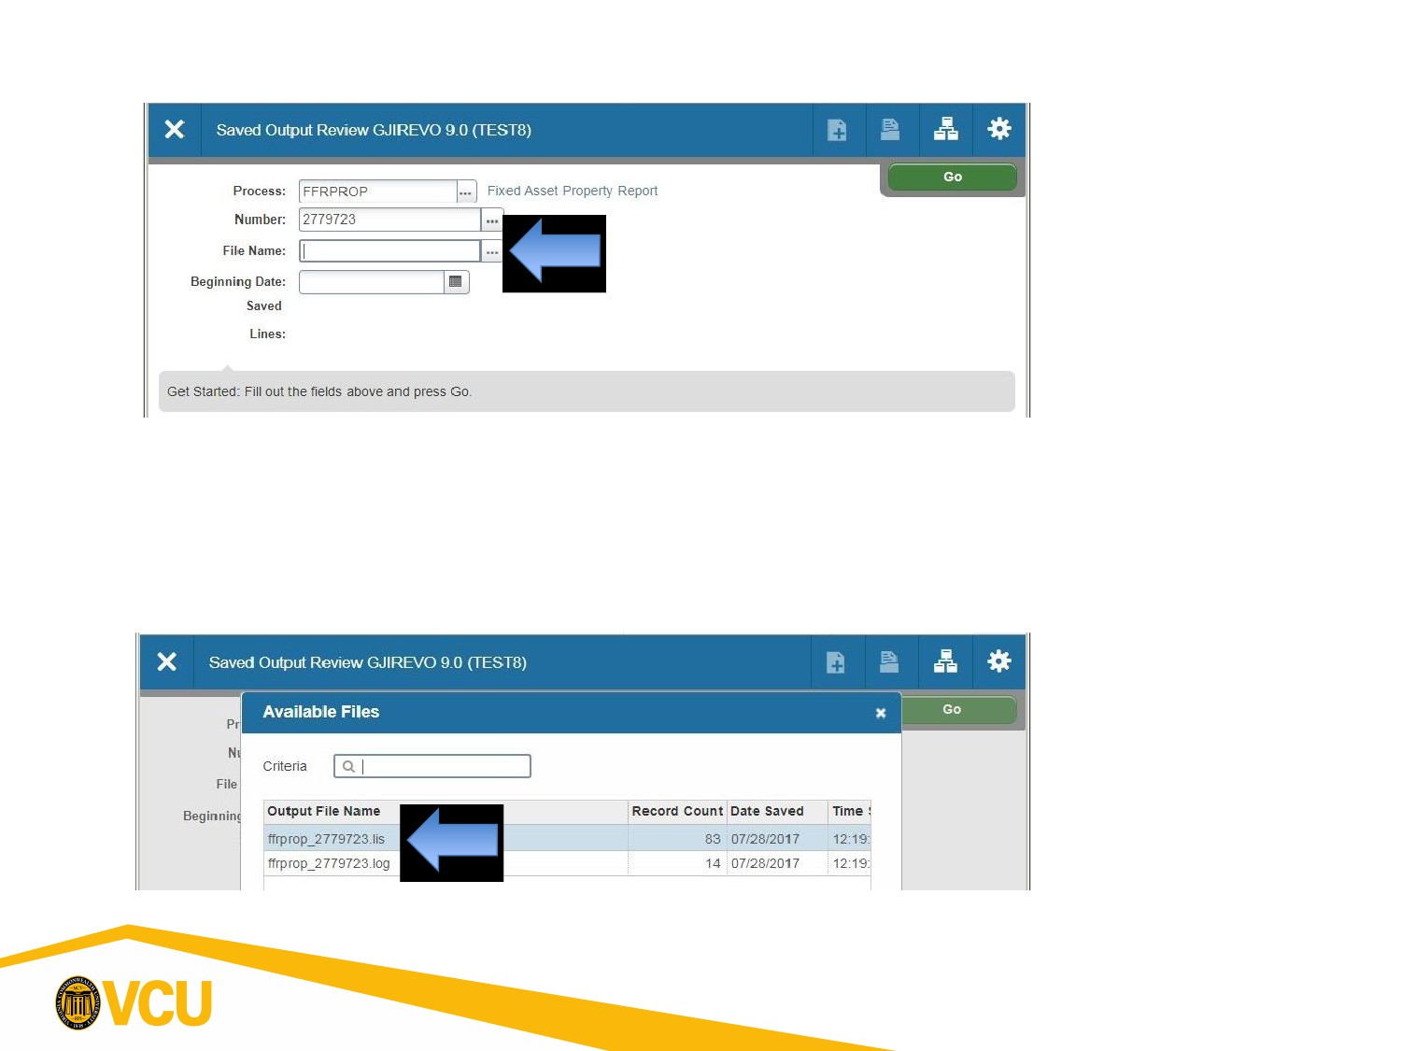
Fixed Asset Policies - Banner Procedures

• Click on the drop down menu (…) for File Name. Two output
files will appear in the main block area.
• Double click on the file ending in .lis.
5

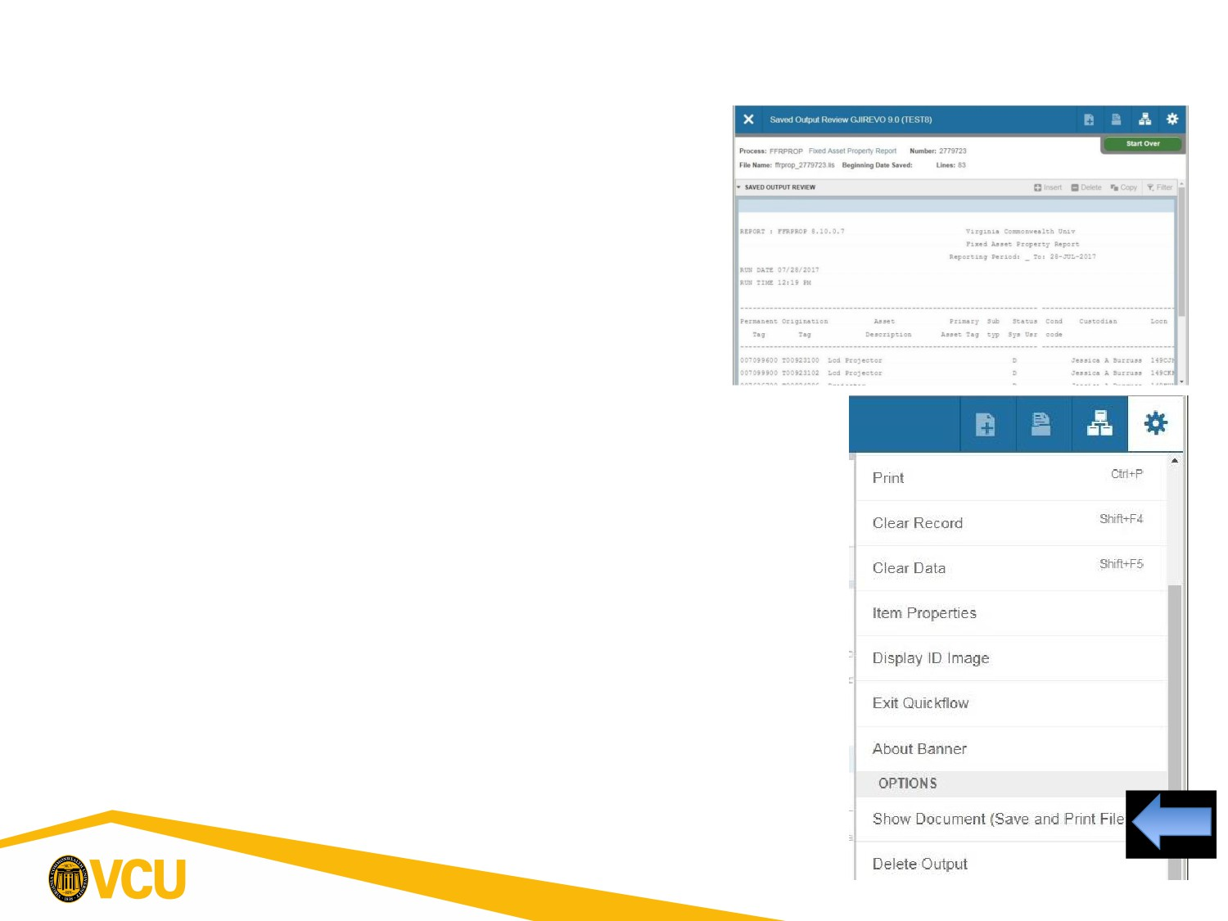
Fixed Asset Policies - Banner Procedures

• From here you can either Print
(below) or export it into Excel.
(Currently Disabled.)
• To Print, select Tools (gear) and
Show Document (Save and Print
File).
• It will ask to open in a browser,
click Yes.
• If pop-ups are blocked, change
your browser to allow them for
Banner 9.
• A New Tab or Window will open,
save or print from here as usual.
6

