There are many useful Banner pages that deal with purchase orders and vendors. Let’s look at a few of
them. FOIDOCH (Document History) gives you a comprehensive look at purchase orders and other
documents. With a PO number, you can view information about the PO, invoices received and the
corresponding receiving entries. You can access FOIDOCH from the Banner Welcome page by simply
typing in the page name.

Enter the page name. No
difference than when typing in
other pages you are planning to
use

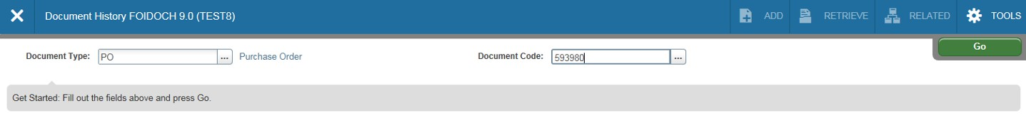Type PO in the Document Type box. Tab to Document Code and type in your PO number (without EP). Click on the Go icon.

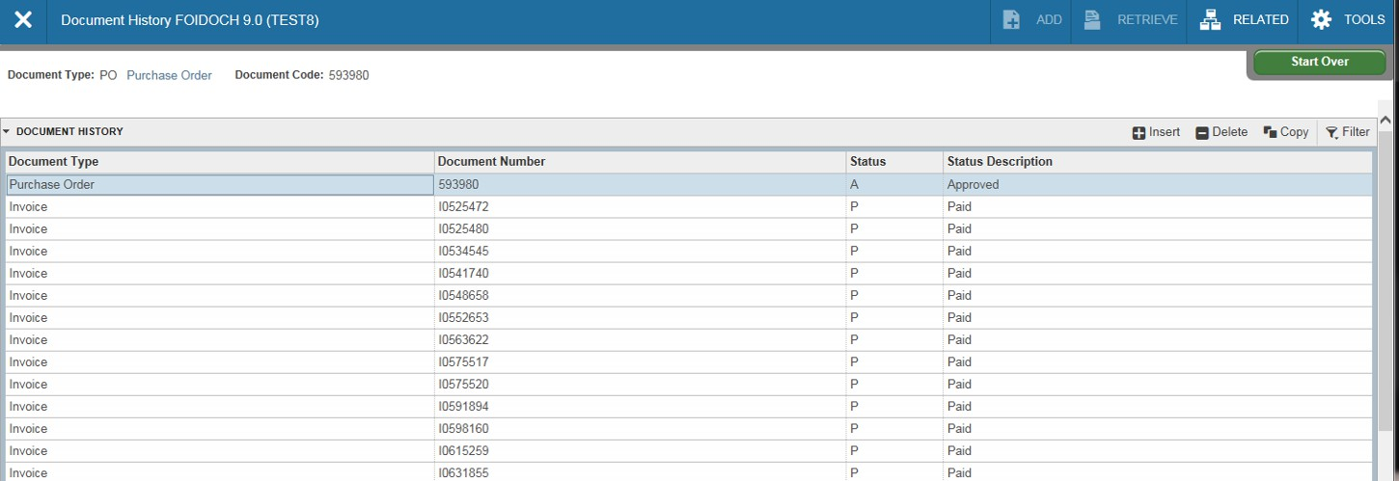From here you can navigate to specific information about the purchase order, invoices for
that purchase order, Banner receivers completed for the invoices and the checks disbursed.

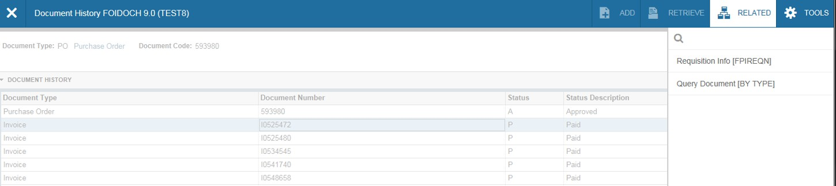To view a specific item, click in the field where the item is listed. In this example,
we’ve selected an invoice. Hit F3 or under “Related”, select Query Document.

Click on the invoice number. Select
Related/Query Document (by type)

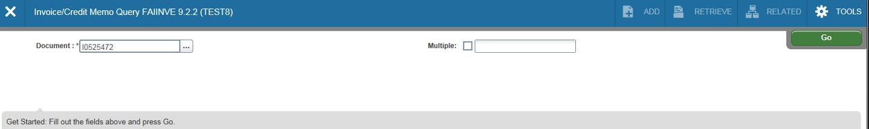page FAIINVE (Invoice query) will open. After selecting Query Document, the
invoice number previously selected will appear in the document field. Select the
“Go” icon. Information on the invoice will then appear.

Previously selected invoice number.
Select the Go icon

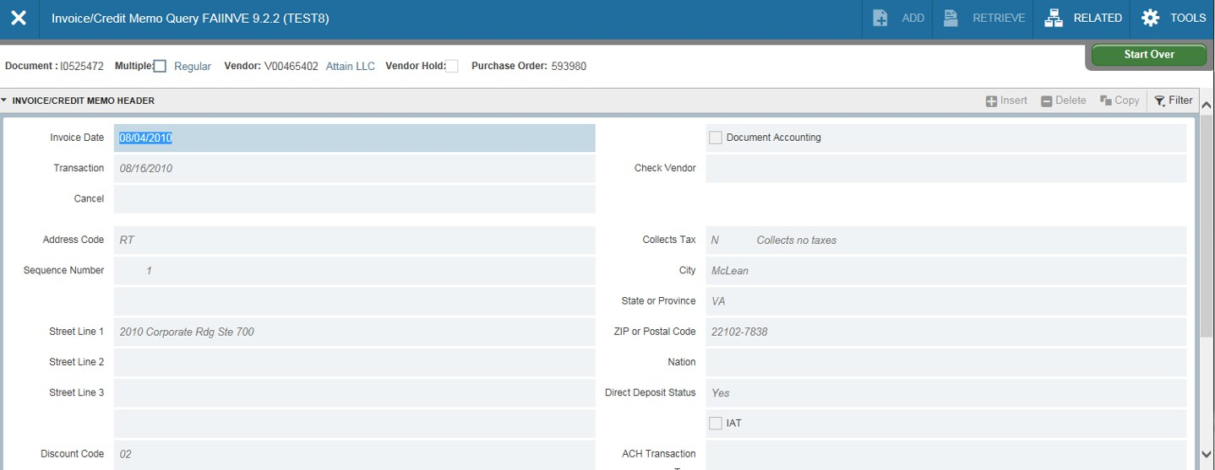page FAIINVE can also be accessed from the Welcome page. Enter the invoice number in the document field and Select the Go icon.

Information on previously selected
invoice number.
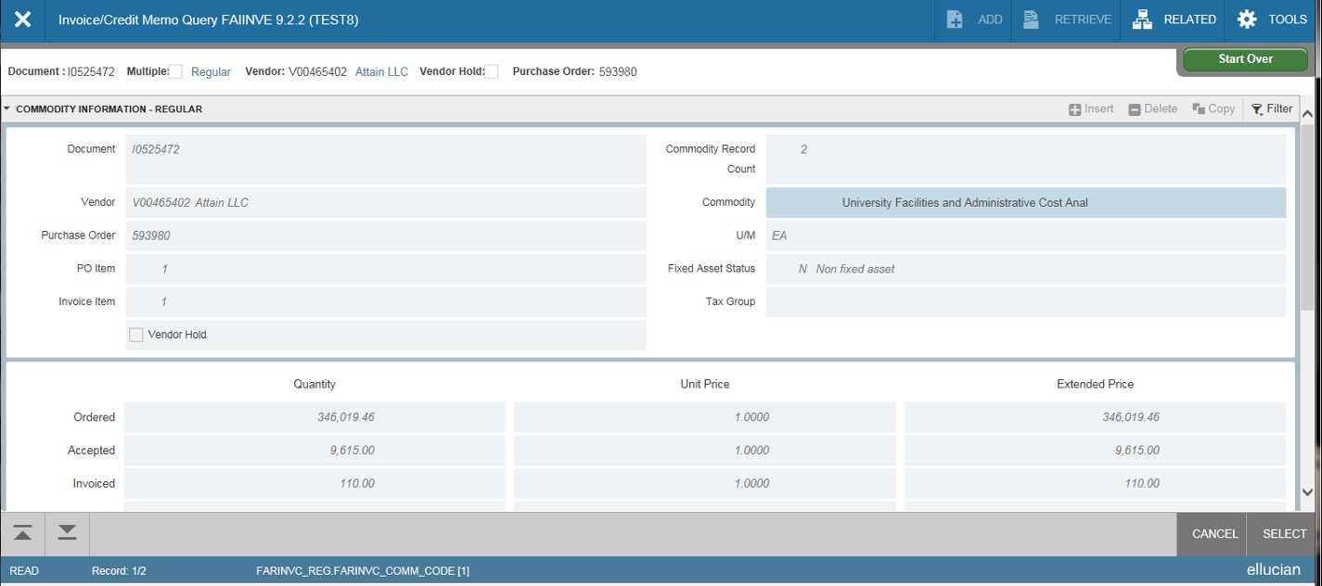Information for the invoice number previously selected will appear. Use the up/down tabs located in the bottom left to view different sections of the
document.

Use up/down tabs to move through the
document.
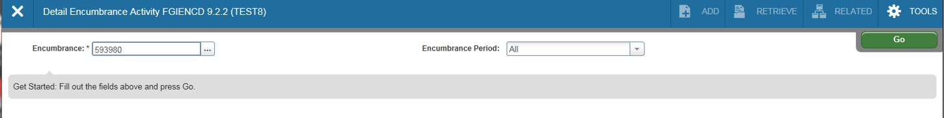Another useful page for purchase orders is FGIENCD (Encumbrance Detail). From the Welcome
page type in page FGIENCD, enter the purchase order number (do not include EP). Select the Go
icon.

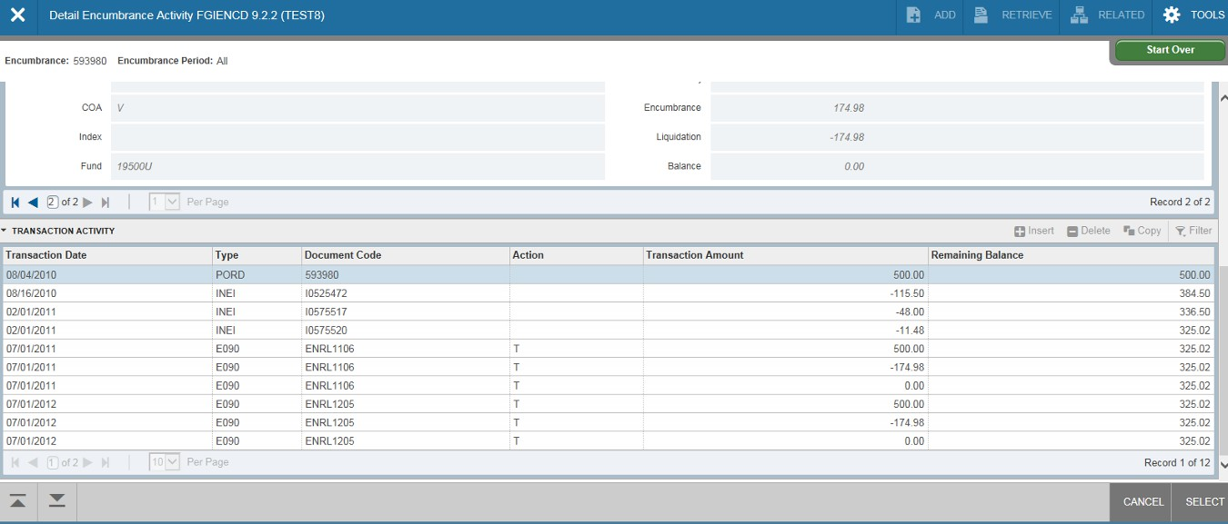FGIENCD (continued)

Document types.

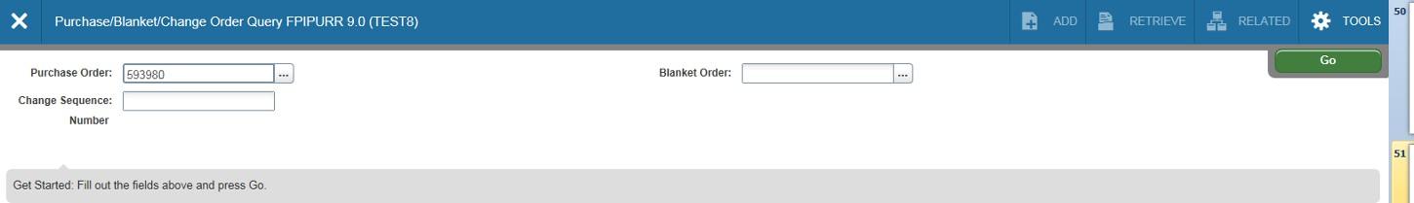Type FPIPURR (Purchase/Blanket/Change Order Inquiry) from the Welcome page; this page is useful when you’re looking for purchase order origination information. Type in the PO
number (no EP) and select the Go icon.

